RESEARCH PROTOCOL TEMPLATE PHASE II COMBINATION AGENTS
Long Form

The George Washington University Cancer Center
800 22nd Street, NW
Suite 8000
Washington, DC 20052

August 2018

TEMPLATE INSTRUCTIONS

The Protocol Template document is a tool to facilitate rapid protocol development. It is not intended to supersede the role of the Principal Investigator in the authoring and scientific development of the protocol. It contains the “boilerplate” language commonly required in investigator-initiated protocols. All sections may be modified as necessary to meet the scientific aims of the study and development of the protocol.

Each protocol template provides standard language plus instructions and prompts for information.

- If a section is not appropriate for a given study, please insert “Not Applicable” after the section number and delete unneeded text.

- All protocol template instructions are in BLUE italics and prompts are shown as FORM FIELDS. Examples are highlighted in yellow highlight.

- Delete the italicized instructions and examples as you complete the information requested.

THE GEORGE WASHINGTON UNIVERSITY CANCER CENTER

STUDY NUMBER: Number will be assigned by the GW Cancer Center at time of PRMC Submission

Example GW12345

STUDY TITLE: Please enter the full title:

PRINCIPAL INVESTIGATOR:

1. A study can only have one Principal Investigator.

The Principal Investigator must be a physician and is responsible for all study conduct.

The Lead Institution/Lead Principal Investigator refers to the physician who is submitting the protocol to the PRMC and IRB.

CO- INVESTIGATOR:

List co-investigators alphabetically by site in the following order:

The George Washington University Cancer Center, Lead Institution, Main Site The George Washington University Cancer Center, Lead Institution, Regional Sites

The George Washington University Cancer Center, Non-Lead Institution, Main Site The George Washington University Cancer Center, Non-Lead Institution, Regional Sites

*Affiliates (Multi-Institutional)
*Affiliate’s Regional Sites

*If this is a multi-institutional study, the protocol title page should include the name of each participating institution, the investigator responsible for the study at that institution, and his/her telephone # and e-mail address.

Name of Physician, MD
The George Washington University Cancer Center
Name of Institution
Street Address City, State, Zip
Telephone including area code Email address

List additional co-investigators

STATISTICIAN: Name of Statistician, Degree
The George Washington University Cancer Center
Name of Cancer Center
Street Address City, State, Zip
Telephone including area code Email address

SPONSOR: The George Washington University Cancer Center

SUPPORT: List any support/grant #s

Examples: U01, R01, Peer Review Sponsor (Komen), Pharmaceutical Company

SUPPLIED AGENT(S): Name of Supplied Agent, if applicable IND #: if applicable Enter Supplier’s Name

OTHER AGENT(S): Name of Agent

SCHEMA

This section should contain a representation of the research project using a diagram, flow chart, narrative, or combination of these.

Doses should be stated as exact dose in units (e.g., mg/m2, mcg/kg, etc) rather than as a percentage.

Example:

GW 12345: Randomized phase II trial, Comparing Pemetrexed plus Erlotinib to Pemetrexed Alone in EGFR TKI-Responsive Non-Small Cell Lung Cancer

Study schema

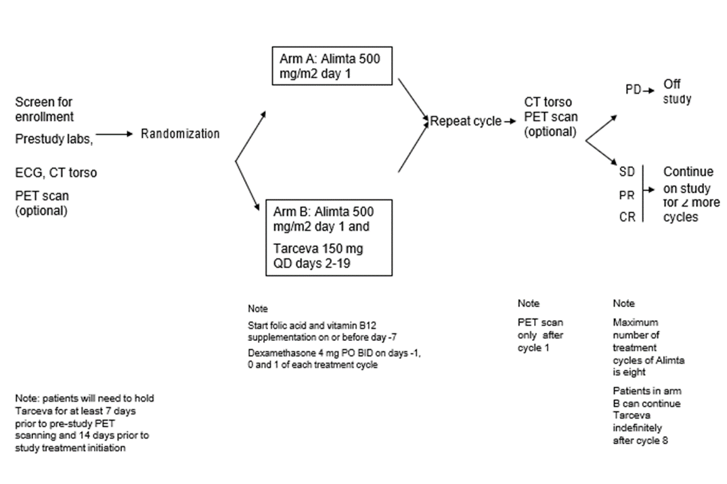

Example: Phase I/II Safety Study

GW 12345: Phase I-II Study Evaluating the Safety and Clinical Efficacy of Temsirolimus and Bevacizumab in Patients with Chemotherapy Resistant Castrate Progressive Prostate Cancer (CPPCA)

Dose level | Temsirolimus | AVASTIN
-1 | 15 mg IV weekly | 5 mg/kg IV  every 2 weeks
0 | 15 mg IV weekly | 10 mg/kg IV  every 2 weeks
1* | 20 mg IV weekly | 10 mg/kg IV  every 2 weeks
2** | 25 mg IV weekly | 10 mg/kg IV  every 2 weeks

* Starting dose

** If no DLT is found at dose level 2, the phase II portion of the study will continue at that dose level.

Example: Phase II Clinical Activity / Safety Study

Weeks (1 cycle = 4 weeks)
WEEKS
T T T T T T T T T T T

PD or Drug Intolerance

Temsirolimus 25mg IV weekly and AVASTIN 10mg/kg IV every 2 weeks*, starting week 2
*(From Phase I safety data)

The following is a summary of the sections that comprise a protocol, listed in the order in which they should appear, along with a brief description of the information contained in each section. This format must be used for all investigator-initiated protocols. Complete each section as applicable.
TABLE OF CONTENTS

SCHEMA

1.0 INTRODUCTION
  - Name of Study Disease
  - Name of Investigational Agent #1
  - Name of Investigational Agent #2 if applicable
  - Other Agent if applicable
  - Rationale

2.0 OBJECTIVES
  - Primary Objective
  - Secondary Objective(s)

3.0 STUDY DESIGN

4.0 PATIENT SELECTION
  - Inclusion Criteria
  - Exclusion Criteria
  - Inclusion of Women and Minorities

5.0 REGISTRATION or RANDOMIZATION, if applicable

6.0 TREATMENT PLAN
  - Agent Administration
    - Name of Investigational Agent(s)
    - Name of Other Agent(s)
    - Name of Other Modality(s) or Procedures if applicable
  - General Concomitant Medications and Supportive Care Guidelines
  - Duration of Therapy
  - Duration of Follow Up

7.0 DOSE DELAYS / DOSE MODIFICATIONS

8.0 ADVERSE EVENTS: LIST AND REPORTING REQUIREMENTS
  - Adverse Events and Potential Risk List
    - Name of Investigational Agent(s)
    - Name of Commercial Agent(s)
  - Definitions
    - Adverse Events
    - Significance of an Adverse Event

    - Serious Adverse Events
    - Expectedness
    - Attribution
  - Reporting Procedures for All Adverse Events
  - Serious Adverse Event Reporting Procedures
    - Reporting
    - FDA Reporting
    - Multi-Center Trials
  - Data Safety Toxicity Committee

9.0 PHARMACEUTICAL INFORMATION
  - Name of Investigational Agent(s)
  - Name of Commercial Agent(s)

10.0 CORRELATIVE / SPECIAL STUDIES if applicable
  - Name of Correlative Study #1
  - Name of Correlative Study #2 if applicable
  - Name of Correlative Study #3 if applicable

11.0 STUDY PARAMETERS AND CALENDAR
  - Study Parameters
  - Calendar

12.0 MEASUREMENT OF EFFECT choose solid tumors / hematologic tumors
  - Antitumor Effect – Solid Tumors
  - Antitumor Effect – Hematologic Tumors
  - Other Response Parameters

13.0 RECORDS TO BE KEPT/REGULATORY CONSIDERATIONS
  - Data Reporting
  - Regulatory Considerations

14.0 STATISTICAL CONSIDERATIONS REFERENCES

APPENDICES

The investigator may choose from the following appendices and modify per protocol specifications.

APPENDIX
Allred Score for ER Status

APPENDIX
ECOG Performance Status Criteria

APPENDIX
ECOG / Karnofsky Performance Status Criteria

APPENDIX
ECOG (Zubrod) Performance Status Criteria

APPENDIX
FACT-G

APPENDIX
IMWG Criteria

APPENDIX
Medications That May Cause QTc Prolongation

APPENDIX
NYHA Cardiac Classification

APPENDIX
Patient Pill Diary

Single or Combo mgs

APPENDIX
Patient Pill Diary

Twice Daily Dosing

APPENDIX
Potential CYP3A4 Interactions

APPENDIX
RANO Criteria Tables for High Grade Gliomas

APPENDIX
VES-13

The investigator must supply additional appendices as needed including questionnaires and surveys.

1.0 INTRODUCTION

  - Study Disease / Stage

Please be specific in the title for disease specific studies.

Example: “Advanced Biliary Cancers” versus “Advanced Cancers”

Please provide background and treatment information on the study disease.

  - Investigational Agent #1

Please include the following information in the appropriate sub-headers below.

Please provide background information below on each investigational agent, including information to support safety issues and the rationale for the starting dose and regimen chosen. Please also provide information on the mechanism of action, summaries and clinical significance of non-clinical and clinical studies, non-clinical and clinical pharmacokinetics, and major route of elimination. If available, please include information on the metabolism of the investigational agent in humans and its potential for drug interactions (e.g., via the P450 enzyme system).

    - Preclinical Data

Include any animal safety in the explanation of any existing clinical or preclinical data about the combination of agent(s) or treatment.

    - Clinical Data to Date

Summarize the available clinical study data with relevance to the protocol under development. If none is available, include a statement that there is no available clinical research data to date on the investigational product.

    - Clinical Pharmacokinetics

Be sure to re-number from here forward according to the total # of agents.

  - Investigational Agent #2

    - Preclinical Data

    - Clinical Data

    - Clinical Pharmacokinetics

  - Other Agent(s) if applicable

Please provide background information on other agent(s) and/or treatments in this study, including information to support safety issues and the rationale for the proposed starting dose scheme, if applicable.

    - Preclinical Data

    - Clinical data

    - Clinical Pharmacokinetics

Add additional agents as applicable for study.

  - Rationale

Please provide the background and rationale for evaluating this combination therapy in this disease. Include the rationale for the proposed starting doses as well as route of administration and dosage period.

2.0 OBJECTIVES

Describe the overall objectives and purpose of the study keeping in mind that objectives must be measurable. Records to be kept should capture the measurement. Study parameters (calendar) should indicate when captured.

  - Primary Objective

It is preferable to have only “one” primary objective. What scientific question are you trying to answer?

Example:

- To evaluate whether Name of Agent #1 added to Name of Agent #2 in patients with advanced non-small cell lung cancer leads to an improved progression-free survival as compared to Name of Agent #2 alone.

Secondary Objective(s)

Example:

- To evaluate the effect of Name of Agent #1 on the response rate to Name of Agent #2 in patients with advanced non-small cell lung cancer as compared to Name of Agent #2 alone.

- To evaluate whether Name of Agent #1 added to Name of Agent #2 in patients with advanced non-small cell lung cancer leads to an improved overall survival as compared to Name of Agent
#2 alone.

- To evaluate the effect of Name of Agent #1 on the disease stabilization (CR + PR + SD) rate to Name of Agent #2 in patients with advanced non-small cell lung cancer as compared to Name of Agent #2 alone.

- To evaluate the utility of early PET scanning (baseline versus 1 cycle of protocol therapy) on overall disease assessment and prediction of treatment responsiveness.

Example:

Primary Objective

- The primary objective of the Phase I portion of the study is to determine the maximum tolerated dose (MTD) of Name of Agent #1 in combination with Name of Agent #2 in subjects with Name of Disease.

- The primary objective for the Phase II portion of this study is to evaluate the objective response frequency of the combination of Name of Agent #1 and Name of Agent #2 in subjects with Name of Disease.

Secondary Objective(s)

    - To evaluate the effect of the combination of Name of Agent #1 and Name of Agent #2 on time to clinical progression and overall survival in subjects with Name of Disease.

- To further evaluate the safety of Name of Agent #1 given in combination with Name of Agent #2 in subjects with Name of Disease at the dose established in the Phase I safety phase.

3.0 STUDY DESIGN

This section should include: the type of trial design of the study, stages, number of subjects and expected duration of subject participation. It is not necessary to state expected time for accrual to be completed; however, this will be required in the PRMC application.

  - Study design including dose escalation / cohorts

The schema is sometimes reinserted in this section.

Examples: Phase II Randomized

Randomized, phase II study of palliative pemetrexed chemotherapy versus palliative pemetrexed chemotherapy plus erlotinib in patients who derived a clinical benefit from erlotinib, but now have evidence of progressive disease.

This is a randomized phase III trial including patients with Small Cell Lung Cancer including two experimental treatment arms (70 Gy once daily radiotherapy and 61.2 Gy concomitant boost radiotherapy) and a standard treatment arm (45 Gy twice daily radiotherapy). An interim analysis, conducted after accrual of 30 patients per arm, will select one experimental arm based upon a comparison of treatment related toxicity. The most toxic experimental arm will be discontinued, and the trial will continue comparing standard therapy to the selected experimental regimen.

Number of Subjects

Provide the number of subjects that will be included in the study using a sentence format.

  - Replacement of Subjects

The replacement of subjects is protocol specific and needs to be tailored to the trial.

Example:

All subjects who have received at least one dose of study agent, but have discontinued study agent prior to the first scheduled response assessment are evaluable for toxicity, but are not evaluable for study endpoints.

Therefore, subjects who are not evaluable for study endpoints may be replaced. However, patients with progressive disease will be considered evaluable after they have received the initial doses of protocol treatment.

  - Expected Duration of Subject Participation [Duplicate in Sections 6.3 and 6.4]

    - Duration of Therapy

In the absence of treatment delays due to adverse events, treatment may continue for # cycles or until one of the following criteria applies:

- Disease progression,

- Intercurrent illness that prevents further administration of treatment,

- The investigator considers it, for safety reasons, to be in the best interest of the patient.

- Unacceptable adverse event(s) [be specific]

Example:
Unacceptable treatment related toxicity, NCI CTC AE version 4.0. Grade 3 or 4 that fails to recover to baseline or < Grade 3 in the absence of treatment within 4 weeks],

Example:
any toxicity or other issue that causes a delay of study drug administration by more than 4 weeks,

- General or specific changes in the patient’s condition render the patient unacceptable for further treatment in the judgment of the investigator,

- Patient decision to withdraw from treatment (partial consent) or from the study (full consent),

- Pregnancy during the course of the study for a child-bearing participant

- Death, or

- Sponsor reserves the right to temporarily suspend or prematurely discontinue this study.

The date and reason for discontinuation must be documented. Every effort should be made to complete the appropriate assessments.

    - Duration of Follow Up

Investigators must be sure to match the duration of follow-up with the calendar regardless if survival is the endpoint of a study.

Patients will be followed for toxicity for 30 days after treatment has been discontinued or until death, whichever occurs first.

The clinical course of each event will be followed until resolution, stabilization, or until it has been determined that the study treatment or participation is not the cause. [The investigator may want to consider a cut off of 6 months.]

Serious adverse events that are still ongoing at the end of the study period will necessitate follow-up to determine the final outcome. Any serious adverse event that occurs after the study period and is considered to be possibly related to the study treatment or study participation will be recorded and reported immediately.

4.0 PATIENT SELECTION

Each of the criteria in the checklist that follows must be met in order for a patient to be considered eligible for this study. Use the checklist to confirm a patient’s eligibility. The checklist must be completed for each patient and must be signed and dated by the treating physician.

Patient’s Name

Medical Record #

Research Nurse /
Study Coordinator Signature: Date

Treating Physician [Print]

Treating Physician Signature:
Date

BE AWARE OF CRITERIA PRONE TO DEVIATIONS!

The protocol must be written gender sensitive, if applicable to study.

Examples:

- Patients must be “males” with histologically confirmed adenocarcinoma of the “prostate”.

- Patients must be “females” with histologically confirmed adenocarcinoma of the “breast”.

- “Women and men” with histologically confirmed adenocarcinoma of the “breast”.

PARAGRAPHS IDENTIFIED WITH AN RED ASTERISK () INDICATE REQUIRED CRITERIA.

  - Inclusion Criteria

Inclusion Criteria must describe the subject population that you want to include in the study. Each statement must be able to be placed into the form of a question with a “positive” response received.

Create a numbered list of criteria applicable to the protocol that subjects must meet to be eligible for study enrollment.

Patients must meet all of the following inclusion criteria to be eligible for enrollment:

*4.1.1 Patients must have histologically or cytologically confirmed malignancy that is metastatic or unresectable and for which standard curative or palliative measures do not exist or are no longer effective.

OR

*4.1.1 Patients must have histologically or cytologically confirmed Name of Disease.

Please specify eligible disease(s)/stage(s) as well as if staging is pathological or clinical.

*4.1.2 Please state allowable types and amount of prior therapy [select as appropriate].

Chemotherapy, or Biological therapy, or
Radiation therapy and (amount) of prior therapy.

As appropriate, define any limitations on prior therapy and the time from last prior regimen.

Example: up to 2 prior chemotherapy regimens for metastatic disease. [OR: There is no restriction on the number of prior regimens.]

Example: no more than 6 cycles of an alkylating agent; no more than 450 mg/m2 doxorubicin for agents with expected cumulative cardiotoxicity.

Include separate definitions for duration as needed:

Example: at least 4 weeks since prior chemotherapy or radiation therapy, 6 weeks if the last regimen included nitrosoureas or mitomycin C.

**If applicable, provide guidance on how to count prior lines of therapy and breaks in therapy.

Include site/total dose for prior radiation exposure as needed.

Example: no more than 3000 cGy to fields including
% of bone marrow. A

diagram/table of the percentage of bone marrow contained in various skeletal regions is shown in Appendix .

Example:
No radiation therapy to the index lesion (i.e., the lesion to be measured) if there is only 1 such lesion. If there is more than 1 lesion, at least 1 must remain free of prior radiation therapy.

4.1.3 Age >18 years. Please state reason for age restriction. If applicable, the following text can be used.

Because no dosing or adverse event data are currently available on the use of Name of Agent in combination with Other Agents in patients <18 years of age, children are excluded from this study.

*4.1.4 Performance status

(not both):
[See Appendix A]. Choose one method

Example: ECOG Performance status < 2

ECOG PS =
Date:

Example: Karnofsky Performance status > 60%

Karnofsky PS = _ Date:

4.1.5 Life expectancy of > # weeks or months, in the opinion of and as documented by the investigator. [Example of protocol specific inclusion which can sometimes be too restrictive]

*4.1.6 Patients must have normal organ and marrow function as defined below:

OR

Patients must have adequate hematologic, hepatic, and renal function as defined below:

Please review for relevance to the specific study and modify.

Example:

4.1.6.1 Hemoglobin > 10.0 g/dl
Hemoglobin: _ Date of Test:

4.1.6.2 Leukocytes >3,000/mcL
Leukocytes: _ Date of Test:

Note: use leukocyte count in eligibility only if clearly necessary. Some patients with adequate ANC have a clinically irrelevant low leukocyte count and are needlessly excluded.

4.1.6.3 Absolute neutrophil count > 1,500/mcL Absolute neutrophil count: Date of Test:

4.1.6.4 Platelet count > 100,000/mcL
Platelet count: Date of Test:

4.1.6.5 Total bilirubin within normal institutional limits Total bilirubin: Date of Test:

4.1.6.6 AST (SGOT) < 2.5 X institutional upper limit of normal AST (SGOT):
Date of Test:

4.1.6.7 ALT (SGPT) < 2.5 X institutional upper limit of normal ALT (SGPT):
Date of Test:

4.1.6.8 Serum Creatinine within normal institutional limits Serum Creatinine: Date of Test:

OR

Creatinine clearance > 60 mL/min/1.73 m2 for patients with creatinine levels above institutional normal
Creatinine clearance: Date of Test:

Note: specify whether calculated (usually Cockcroft-Gualt) or measured necessary.

4.1.7 Please insert other appropriate eligibility criteria.

Example: Subjects are eligible if they have brain metastases.

Example: Subjects treated for brain metastases are eligible if the subject has been neurologically stable for at least 1 month.

Example: Subjects are eligible if no additional treatment is planned for brain metastases.

Example: Subjects are eligible if CNS disease is clinically stable.

Example: Subjects must be off any steroids 7 days prior to the initiation of treatment.

Example: Subjects must be on a stable dose of steroids 7 days prior to the initiation of treatment.

* 4.1.8 Please use or modify the following paragraph as appropriate.

The effects of Name of Agent on the developing human fetus are unknown. For this reason and because Name of Agent Class agent(s) as well as other therapeutic agents used in this study are known to be teratogenic, women of child-bearing potential and men must agree to use adequate contraception (double barrier method of birth control or abstinence) # weeks or
# months prior to study entry, for the duration of study participation and for # weeks or # months after completing treatment.

Should a woman become pregnant or suspect that she is pregnant while she or her partner is participating in this study, she should inform the treating physician immediately.

* 4.1.9 Subjects must have the ability to understand and the willingness to sign a written informed consent document.

Exclusion Criteria

Exclusion Criteria must describe the subject population that you do NOT want to include in the study. Each statement must be able to be placed into the form of a question with a “negative” response received.

Create a numbered list of criteria applicable to the protocol that would exclude a subject from study enrollment.

The presence of any of the following will exclude a patient from study enrollment.

* 4.2.1 Patients who have not recovered from adverse events due to agents administered more than 4 weeks earlier.

OR

* 4.2.1 Prior treatment toxicities must be resolved to < Grade 1 according to NCI CTCAE Version 4.0.

4.2.2 Patients who are receiving any other investigational agents.

4.2.3 To be included if applicable to protocol. Suggested text is provided below:

Patients with untreated brain metastases should be excluded from this clinical trial because of their poor prognosis and because they often develop progressive neurologic dysfunction that would confound the evaluation of neurologic and other adverse events.

4.2.4 History of allergic reactions attributed to compounds of similar chemical or biologic composition to Name of Agent or other agents used in this study.

* 4.2.5 Please state appropriate exclusion criteria relating to concomitant medications or substances that have the potential to affect the activity or pharmacokinetics of the study agent(s).

Examples of such agents or substances include those that interact through the CYP450 isoenzyme system or other sources of drug interactions (e.g., P-glycoprotein). If appropriate, the following text concerning CYP450 interactions may be used or modified.

Patients receiving any medications or substances that are inhibitors or inducers of specify CYP450 enzyme(s) are ineligible. Lists including medications or substances known or with the potential to interact with the specify CYP450 enzyme(s) isoenzymes are provided in Appendix .

* 4.2.6 Patients with uncontrolled intercurrent illness including, but not limited to ongoing or active infection, symptomatic congestive heart failure, unstable angina pectoris, cardiac arrhythmia, or psychiatric illness/social situations that would limit compliance with study requirements.

* 4.2.7 The investigator must state a medical or scientific reason if pregnant or nursing patients will be excluded from the study. Suggested text is provided below:

Pregnant or breastfeeding women are excluded from this study because Name of Agent is Name of Agent Class agent with the potential for teratogenic or abortifacient effects. Because there is an unknown, but potential risk for adverse events in nursing infants secondary to treatment of the mother with Name of Agent, breastfeeding should be discontinued if the mother is treated with Name of Agent. These potential risks may also apply to other agents used in this study.

4.2.8 The investigator must state a medical or scientific reason if patients who are IV-positive will be excluded from the study. Suggested text is provided below:

HIV-positive patients on combination antiretroviral therapy are ineligible because of the potential for pharmacokinetic interactions with Name of Agent. In addition, these patients are at increased risk of lethal infections when treated with marrow suppressive therapy. Appropriate studies will be undertaken in patients receiving combination antiretroviral therapy when indicated.

4.2.9 Insert other appropriate agent-specific exclusion criteria.

Examples for Anti-Angiogenesis Drugs:

Patients with uncontrolled hypertension defined as systolic BP ≥ 150 mmHg or diastolic BP ≥ 90 mmHg, with or without anti-hypertensive medication or history of hypertensive crisis or hypertensive encephalopathy.

Blood Pressure: /

Date Taken:

Patients who have had major surgical procedures or significant traumatic injury within 28 days prior to study treatment.

Date of Last Major Surgery:

Scheduled Day 1 of Protocol Treatment:

* 4.3 Inclusion of Women and Minorities

Make sure you include the appropriate verbiage for the subject population. Suggested text is provided below:

Both men and women and members of all races and ethnic groups are eligible for this trial.

5.0 REGISTRATION or RANDOMIZATION, if applicable

5.1 Registration

All subjects who have been consented are to be registered in the OnCore Database. For those subjects who are consented, but not enrolled, the reason for exclusion must be recorded.

All subjects will be registered through Name of Lead Site and will be provided a study number by calling telephone number of Study Coordinator. Do not include name.

OR

5.1 Randomization if applicable

All subjects who have been consented are to be registered in the OnCore Database. For those subjects who are not enrolled, the reason for exclusion must be recorded.

All subjects will be registered through Name of Lead Site and will be provided a study number by calling telephone number of Study Coordinator. Do not include name.

Describe how the randomization and associated treatment assignment will be made.

The following example must be modified per protocol specifications:

Subjects will be assigned to either Name of Study Agent or Name of Study Agent + Name of Study Agent based on the randomization lists prepared by the Biostatistics Core of the The George Washington University Cancer Center. Randomization will be stratified by performance status (0-1 vs. 2) and smoking status (ever vs. never lifetime). This is a 1:1 randomization.

6.0 TREATMENT PLAN

  - Agent Administration

Describe the treatment regimen planned (agent, dose, route of administration, treatment schedule, and treatment duration). Please provide separate regimen descriptions for different treatment groups of patients as necessary.

The investigator must include the following statement if treatment is required to be administered only on an inpatient basis: Treatment must be administered only on an inpatient basis.

Appropriate dose modifications for Name of Investigational Agent(s) and Name of Other Agent(s) are described in Section 7.0

Reported adverse events and potential risks of Name of Investigational Agent(s) and Name of Other Agent(s) are described in Section 8.0.

No investigational or commercial agents or therapies other than those described below may be administered with the intent to treat the patient's malignancy.

The use of a table is preferred by many to describe the regimen. Example:

TREATMENT REGIMEN DESCRIPTION
Agent | Pre-medicate  / Precautions | Dose | Route | Schedule | Cycle Length
Agent X | Pre-medicate with dexamethasone for 3 days prior to Agent X | 300 mg/m2 in 500 cc NS | IV over 2 hours before Agent Y | Week 1  Days 1-3 | 28 days
Agent Y | Avoid exposure to cold (food, liquids, air) for 24 hr after each dose | 150 g/m2 in  250 cc D5W | IV 1 hr after completion of Agent A through separate IV line | Week 1  Days 1-3
Agent Z a | Take with food | **tablet | PO in the a.m. | Weeks 1+2, Daily
a For orally administered agents, a method for assessing compliance with treatment should be included, i.e., Suggested text is provided below:

a The patient will be provided a Patient Pill Diary [Appendix ] and instructed in its use to record each dose of oral medication. Or place the statement under Section 6.1.1 as shown below.

Example:

TREATMENT REGIMEN DESCRIPTION
Agent | Premedications; Precautions | Dose | Route | Schedule | Cycle Length
Agent #1 | All patients will receive dexamethasone 4 mg IC prior to each Agent #1 infusion. Premedicate with antiemetics as needed for patients developing nausea or vomiting with a  previous dose of Agent #1 | 25 mg/m2 in 500 ml NS or 500 ml 5% dextrose in water | IV infusion within 2 hours after pelvic irradiation using non-DEHP lined administration sets. | Week Days  Week 1 1, 3, 5  Week 2 8, 10, 12  Week 3 15, 17, 19  Week 4 22, 24, 26  Week 5 29, 31, 33 | Weeks 1-5, Three times weekly
Agent #2 | Increased oral intake of fluid should be encouraged 24 hours prior to administration; 1000 ml of  ½ normal saline infused IV one hour prior before Agent #2. Premedicate with antiemetics as needed for patients developing nausea or vomiting with a previous dose of Agent #2. | 40 mg/m2 diluted in 250 ml normal saline, reconstituti on results in a colorless solution | IV infusion at a rate of 1 mg/min, usually infusing over 1 ½ hours (90 minutes) using non- aluminum administration sets; immediately following an additional 1000 ml of ½ normal saline infused over one  hour. | Days  2, 9, 16, 23, 30 | Weeks 1-5, Once weekly
external beam radiation | Skin, antiemetics, or anti- diarrheal medications may be administered as needed. | 1 80 cGy/day | See Section x.x | Weeks 1-5, Daily | Weeks 1-5,  Daily  (25 treatments)
brachytherapy | Antiemetic and anti- diarrheal medication may be administered as needed. | 3000 to 4000cGY in one or multiple fractions using LDR or HDR  techniques | See Section x.x | See Section x.x | See Section x.x

OR you may use a narrative:

    - Name of Investigational Agent #1 Administration

Examples of IV Drug:

Patients will receive Name of Agent mg/m2 on Days 1-3 of each (28 day) cycle. Name of Agent will be administered IV over 2 hours.

Patients will receive Name of Agent mg/m2 by IV on Day 1 of each 21-day cycle. Prior to each Name of Agent treatment, pre-hydrate with at least 1000 ml normal saline and use diuretics per institutional guidelines.

Patients will receive Name of Agent mg/m2 by IV on days 1, 2, and 3 of each 21-day cycle.

Example of capsule/tablet: Patients will receive Name of Agent mg/day orally on an empty stomach / with food in morning in 2 week (14 day) cycles. Patients will be provided a Patient Pill Diary (Appendix ) and instructed in its use to record each dose of oral medication.

Name of Agent administration must be at least 1 hour before or after any other medications. An empty stomach is defined as at least 2 hours after the most recent food intake of any quantity and at least 1 hour before the next food intake. Note: “food intake” is better than “meal” as some may think a snack or smoothie is OK.

Insert a new section for each Investigational Agent.

    - Name of Other Agent(s) Administration

Example: of mFOLFOX6 Administration:

Patients will receive modified FOLFOX6 (mFOLFOX6) on an outpatient basis on Day 1 of each 2 week (14 day) cycle. This regimen consists of concurrent IV administration of 85 mg/m2 Oxaliplatin and 400 mg/m2 Leucovorin over 120 minutes, followed by 400 mg/m2 5- fluorouracil (FU) bolus, then 2400 mg/m2 5-FU as a 46 hour infusion. Am ambulatory infusion pump may be used for the 5-FU infusion. All patients must have central intravenous access (e.g., Mediport, PICC line) for the continuous infusion of 5-FU.

Insert a new section for each Other Agent.

    - Name of Other Modality(s) or Procedures, if applicable

Please provide a detailed description of any other modalities (e.g., surgery, radiotherapy) or procedures (e.g., hematopoietic stem cell transplantation) used in the protocol

treatment. If this study involves no other modalities or procedures, this section should be marked “N/A”.

Radiotherapy

Patients on Arm A will receive treatment 5 days per week, in twice daily fractions, 1.5 Gy per fraction. The total dose will be 45 Gy in 30 fractions. There are no field reductions on this arm and a single PTV (PTV-1) will be used throughout the entire treatment. All fields must be treated daily and the entire PTV must be treated daily. The treatment plan will limit direct irradiation of the spinal cord during the afternoon treatment for the final 10 days of therapy. Radiation therapy (RT) commences on either day 1 of the first cycle of chemotherapy or day 1 of the 2nd cycle of chemotherapy. There will be a minimum of 6 hours between the morning and afternoon fractions.

General Concomitant Medications and Supportive Care Guidelines

State guidelines for use of which concomitant medicines/therapies are permitted during the study, and which concomitant medicines/therapies are not permitted during the study (if applicable). Include any additional rescue therapies or supportive care medications or treatments required for administration of each agent in the treatment.

In addition, the potential for interaction with the cytochrome P450 system should be addressed, if applicable.

Example:
Because there is a potential for interaction of Name of Agent(s) with other concomitantly administered drugs through the cytochrome P450 system, the case report form must capture the concurrent use of all other drugs, over-the-counter medications, or alternative therapies. The Principal Investigator should be alerted if the patient is taking any agent known to affect or with

the potential to affect selected CYP450 isoenzymes. Please refer to Appendix complete list.
for a

Suggestive text, as applicable for supportive care: Patients should receive full supportive care, including transfusions of blood and blood products, cytokines, antibiotics, antiemetics, etc when appropriate.

Duration of Therapy

In the absence of treatment delays due to adverse events, treatment may continue for # cycles or until one of the following criteria applies:

- Disease progression,

- Intercurrent illness that prevents further administration of treatment,

  - The investigator considers it, for safety reasons, to be in the best interest of the patient.

  - Unacceptable adverse event(s) [be specific]

Example: unacceptable treatment related toxicity, NCI CTC AE version 4.0. Grade 3 or 4 that fails to recover to baseline or < Grade 3 in the absence of treatment within 4 weeks],
Example:any toxicity or other issue that causes a delay of study drug administration by more than 4 weeks,

  - General or specific changes in the patient’s condition render the patient unacceptable for further treatment in the judgment of the investigator,

  - Patient decision to withdraw from treatment (partial consent) or from the study (full consent),

  - Pregnancy during the course of the study for a child-bearing participant

  - Death, or

  - Sponsor reserves the right to temporarily suspend or prematurely discontinue this study.

The date and reason for discontinuation must be documented. Every effort should be made to complete the appropriate assessments.

  - Duration of Follow Up

Investigators must be sure to match the duration of follow-up with the calendar regardless if survival is the endpoint of a study.

Patients will be followed for toxicity for 30 days after treatment has been discontinued or until death, whichever occurs first.

The clinical course of each event will be followed until resolution, stabilization, or until it has been determined that the study treatment or participation is not the cause. [The investigator may want to consider a cut off of 6 months.]

Serious adverse events that are still ongoing at the end of the study period will necessitate follow-up to determine the final outcome. Any serious adverse event that occurs after the study period and is considered to be possibly related to the study treatment or study participation will be recorded and reported immediately.

7.0 DOSING DELAYS / DOSE MODIFICATIONS

Treatment modifications/dosing delays and the factors predicating treatment modification should be explicit and clear. If dose modifications or treatment delays are anticipated, please provide a dose de-escalation schema.

All treatment modifications must be expressed as a specific dose or amount rather than as a percentage of the starting or previous dose.

Please consider dosing formulation when calculating dose modifications for ORAL agents. Dose modifications/treatment delays may be presented separately or together as appropriate.
The following table format is provided as an example and should be modified as appropriate for this protocol:

Dose Level | Name of Agent (schedule) | Name of Agent (schedule) | Name of Agent (schedule) | Name of Agent (schedule)
Level 1 (starting dose) | mg | mg | mg | mg
Level -1 (reduction) | mg | mg | mg | mg
Level -2 (reduction) | mg | mg | mg | mg
Level -3 (reduction) | mg | mg | mg | mg

Below are dose modification tables for the following adverse events: nausea, vomiting, diarrhea, neutropenia, and thrombocytopenia. Please use as appropriate. In addition, for your convenience, a blank dose modification table has been provided. Note in the text that if a patient experiences several adverse events and there are conflicting recommendations, the investigator should use the recommended dose adjustment that reduces the dose to the lowest level.

Event Name | Nausea
Grade of Event | Management/Next Dose for Name of Agent | Management/Next Dose for Name of Agent
≤ Grade 1 | No change in dose | No change in dose
Grade 2 | Hold until ≤ Grade 1. Resume at same dose level. | Hold until ≤ Grade 1. Resume at same dose level.

Grade 3 | Hold * until < Grade  2. Resume at one dose level lower, if indicated. ** | Hold * until < Grade  2. Resume at one dose level lower, if indicated. **
Grade 4 | Off protocol therapy | Off protocol therapy
*Patients requiring a delay of >2 weeks should go off protocol therapy.
**Patients requiring > two dose reductions should go off protocol therapy.
Recommended management: antiemetics.

Event Name |  | Vomiting
Grade of Event | Management/Next Dose for Name of Agent | Management/Next Dose for Name of Agent
≤ Grade 1 | No change in dose | No change in dose
Grade 2 | Hold until ≤ Grade 1. Resume at same dose level. | Hold until ≤ Grade 1. Resume at same dose level.
Grade 3 | Hold* until < Grade  2. Resume at one dose level lower, if indicated. ** | Hold* until < Grade  2. Resume at one dose level lower, if indicated. **
Grade 4 | Off protocol therapy | Off protocol therapy
*Patients requiring a delay of >2 weeks should go off protocol therapy.
**Patients requiring > two dose reductions should go off protocol therapy.
Recommended management: antiemetics.

Event Name | Diarrhea
Grade of Event | Management/Next Dose for Name of Agent | Management/Next Dose for Name of Agent
≤ Grade 1 | No change in dose | No change in dose
Grade 2 | Hold until ≤ Grade 1. Resume at same dose level. | Hold until ≤ Grade 1. Resume at same dose level.
Grade 3 | Hold* until < Grade  2. Resume at one dose level lower, if indicated. ** | Hold* until < Grade  2. Resume at one dose level lower, if indicated. **
Grade 4 | Off protocol therapy | Off protocol therapy
*Patients requiring a delay of >2 weeks should go off protocol therapy.
**Patients requiring > two dose reductions should go off protocol therapy.

Recommended management: Loperamide antidiarrheal therapy

Dosage schedule: 4 mg at first onset, followed by 2 mg with each loose motion until diarrhea-free for 12 hours (maximum dosage: 16 mg/24 hours)
Adjunct anti-diarrheal therapy is permitted and should be recorded when used.

Event Name | Neutropenia
Grade of Event | Management/Next Dose for Name of Agent | Management/Next Dose for Name of Agent
≤ Grade 1 | No change in dose | No change in dose
Grade 2 | Hold until ≤ Grade 1. Resume at same dose level. | Hold until ≤ Grade 1. Resume at same dose level.
Grade 3 | Hold* until < Grade  2. Resume at one dose level lower, if indicated. ** | Hold* until < Grade  2. Resume at one dose level lower, if indicated. **
Grade 4 | Off protocol therapy | Off protocol therapy
*Patients requiring a delay of >2 weeks should go off protocol therapy.
**Patients requiring > two dose reductions should go off protocol therapy.
Insert any recommended management guidelines, if appropriate.

Event Name | Thrombocytopenia
Grade of Event | Management/Next Dose for Name of Agent | Management/Next Dose for Name of Agent
≤ Grade 1 | No change in dose | No change in dose
Grade 2 | Hold until ≤ Grade 1. Resume at same dose level. | Hold until ≤ Grade 1. Resume at same dose level.
Grade 3 | Hold* until < Grade  2. Resume at one dose level lower, if indicated. ** | Hold* until < Grade  2. Resume at one dose level lower, if indicated. **
Grade 4 | Off protocol therapy | Off protocol therapy
*Patients requiring a delay of >2 weeks should go off protocol therapy.
**Patients requiring > two dose reductions should go off protocol therapy.
Insert any recommended management guidelines, if appropriate.

Example of Dose Modification Table:

Event Name | Name of Event
Grade of Event | Management/Next Dose for Name of Agent | Management/Next Dose for Name of Agent
≤ Grade 1 | Insert appropriate management guidelines in this column. | Insert appropriate management guidelines in this column.
Grade 2
Grade 3
Grade 4
*Footnote any relevant guidelines regarding how long a delay in therapy
is allowed before patients should go off protocol therapy.
**Footnote any relevant guidelines regarding how many dose reductions are allowed before patients should go off protocol therapy.
Insert any recommended management guidelines, if appropriate.

Other Examples:

Dose Modifications for Neutropenia

Arms A & B

ANC must be ≥ 1500/μL on day 1 of a cycle. For ANC < 1500/μL, hold fludarabine until ANC ≥ 1500/μL, then resume fludarabine at one dose level lower than previous dose (see table in Section 9.2.1). If dose reduction to less than dose level -2 is required for neutropenia, discontinue treatment with fludarabine and rituximab. If fludarabine is delayed for neutropenia, rituximab should also be delayed.

In patients whose baseline (i.e., prior to starting protocol therapy) ANC <1500/μL, these dose
modifications, if required, would not be applied until Cycle 3. Arms C & D
ANC must be ≥ 1500/μL on day 1 of a cycle. For ANC < 1500/μL, hold fludarabine and cyclophosphamide until ANC ≥ 1500/μL, then resume both at one dose level lower than previous dose (see table in Section 9.2.1). If dose reduction to less than dose level -2 is required for neutropenia, discontinue treatment with fludarabine, cyclophosphamide, and rituximab. If fludarabine and cyclophosphamide are delayed for neutropenia, rituximab should also be delayed.

In patients whose baseline (i.e., prior to starting protocol therapy) ANC <1500/μL, these dose
modifications, if required, would not be applied until Cycle 3.

Dose Modifications for Febrile Neutropenia

Arms A & B

For febrile neutropenia, hold fludarabine until fever resolves and ANC ≥ 1500/μL, then resume fludarabine at one dose level lower than the previous dose (see table in Section 9.2.1). If dose reduction to less than dose level -2 is required for febrile neutropenia, discontinue treatment with fludarabine and rituximab. If fludarabine is delayed for febrile neutropenia, rituximab should also be delayed.

Arms C & D

For febrile neutropenia, hold fludarabine and cyclophosphamide until fever resolves and ANC ≥ 1500/μL, then resume both at one dose level lower than the previous dose (see table in Section 9.2.1). If dose reduction to less than dose level -2 is required for febrile neutropenia, discontinue treatment with fludarabine, cyclophosphamide, and rituximab. If fludarabine and cyclophosphamide are delayed for febrile neutropenia, rituximab should also be delayed.

Examples for Radiotherapy:

Radiotherapy Dose Modifications for In-field Non-Hematologic Toxicities

Radiation treatment will be interrupted for grade 4 in-field toxicity and/or grade 4 neutropenia with fever.

Aggressive supportive care is encouraged throughout the course of radiotherapy. If the patient is near completion of therapy, then every attempt should be made to complete treatment despite acute toxicity. Otherwise, treatment should be restarted when the accompanying toxicity declines to ≤ grade 2.

If treatment is interrupted for more than 3 weeks due to non-hematologic toxicity, remove the patient from protocol treatment.

Provide a treatment modification table for In-Field Non-Hematologic Toxicities

  - ADVERSE EVENTS: LIST AND REPORTING REQUIREMENTS

The following is a list of AEs (Section 8.1) and the reporting requirements associated with observed AEs (Sections 8.3 and 8.4).

The clinical course of each event will be followed until resolution, stabilization, or until it has been determined that the study treatment or participation is not the cause.

Serious adverse events that are still ongoing at the end of the study period will necessitate follow-up to determine the final outcome. Any serious adverse event that occurs after the study period and is considered to be possibly related to the study treatment or study participation will be recorded and reported immediately.

Adverse Events and Potential Risks

    - Name of Agent

For an investigational agent, please include a comprehensive list of all reported adverse events and any potential risks for each agent (such as the toxicities seen with another agent of the same class or risks seen in animals administered this agent) as provided by the manufacturer.

For a commercial agent, please provide a list of those adverse events most likely to occur on this study, and refer the reader to the package insert(s) for the comprehensive list of adverse events.

  - Definitions

    - Adverse Events

An adverse event (AE) is any unfavorable or unintended event, physical or psychological, associated with a research study, which causes harm or injury to a research participant as a result of the participant’s involvement in a research study. The event can include abnormal laboratory findings, symptoms, or disease associated with the research study. The event does not necessarily have to have a causal relationship with the research, any risk associated with the research, the research intervention, or the research assessments.

Adverse events may be the result of the interventions and interactions used in the research; the collection of identifiable private information in the research; an underlying disease, disorder, or condition of the subject; and/or other circumstances unrelated to the research or any underlying disease, disorder, or condition of the subject. In general, adverse events that are at least partially the result of (a) or (b) would be considered related to the research, whereas adverse events solely related to (c) or (d) would be considered unrelated to the research.

External adverse events are adverse events experienced by subjects enrolled in multicenter clinical trials at sites other than the site(s) over which the Institutional Review Board has jurisdiction.

Internal adverse events are adverse events experienced by subjects enrolled at the site(s) under the IRB’s jurisdiction for either multicenter or single-center research projects.

    - The significance of an adverse event is used to describe the patient/event outcome or action criteria associated with events that pose a threat to a patient’s life or functioning (i.e., moderate, severe or life threatening). Based on the National Cancer Institute Guidelines for the Cancer Therapy Evaluation Program, severity can be defined by the following grades of events:

Grades 1 are mild adverse events. (e.g., minor event requiring no specific medical intervention; asymptomatic laboratory findings only; marginal clinical relevance)

Grades 2 are moderate adverse events (e.g., minimal intervention; local intervention; non- invasive intervention; transfusion; elective interventional radiological procedure; therapeutic endoscopy or operation).

Grades 3 are severe and undesirable adverse events (e.g., significant symptoms requiring hospitalization or invasive intervention; transfusion; elective interventional radiological procedure; therapeutic endoscopy or operation).

Grades 4 are life threatening or disabling adverse events (e.g., complicated by acute, life- threatening metabolic or cardiovascular complications such as circulatory failure, hemorrhage, sepsis; life–threatening physiologic consequences; need for intensive care or emergent invasive procedure; emergent interventional radiological procedure, therapeutic endoscopy or operation).

Grades 5 are fatal adverse event resulting in death.

Serious Adverse Events
A serious adverse event (SAE) is any adverse experience occurring at any dose that results in any of the following outcomes:
- Results in death.
- Is a life-threatening adverse experience. The term life-threatening in the definition of serious refers to an adverse event in which the subject was at risk of death at the time of the event. It does not refer to an adverse event which hypothetically might have caused death if it were more severe.
- Requires inpatient hospitalization or prolongation of existing hospitalization. Any adverse event leading to hospitalization or prolongation of hospitalization will be considered as Serious, UNLESS at least one of the following expectations is met:
  - The admission results in a hospital stay of less than 12 hours OR

  - The admission is pre-planned (i.e., elective or scheduled surgery arranged prior to the start of the study) OR
  - The admission is not associated with an adverse event (e.g., social hospitalization for purposes of respite care.
However it should be noted that invasive treatment during any hospitalization may fulfill the criteria of “medically important” and as such may be reportable as a serious adverse event dependant on clinical judgment. In addition where local regulatory authorities specifically require a more stringent definition, the local regulation takes precedent.
- Results in persistent or significant disability/incapacity. The definition of disability is a substantial disruption of a person’s ability to conduct normal life’s functions.

Is a congenital anomaly/birth defect.
- Is an important medical event. Important medical events that may not result death, be life-threatening, or require hospitalization may be considered a serious adverse experience when, based upon appropriate medical judgment, they may jeopardize the patient or subject and may require medical or surgical intervention to prevent one of the outcomes listed in this definition. Examples of such medical events include allergic bronchospasm requiring intensive treatment in an emergency room or at home, blood disease or disorders, or convulsions that do not result in inpatient hospitalization, or the development of drug dependency or drug abuse.

Expectedness
Adverse Events can be Expected or Unexpected.

An expected adverse event is an event previously known or anticipated to result from participation in the research study or any underlying disease, disorder, or condition of the subject. The event is usually listed in the Investigator Brochure, consent form or research protocol.

An unexpected adverse event is an adverse event not previously known or anticipated to result from the research study or any underlying disease, disorder, or condition of the subject.

Attribution
Attribution is the relationship between an adverse event or serious adverse event and the study drug. Attribution will be assigned as follows:

      - Definite – The AE is clearly related to the study drug.
      - Probable – The AE is likely related to the study drug.
      - Possible – The AE may be related to the study drug.
      - Unlikely – The AE is doubtfully related to the study drug.
      - Unrelated – The AE is clearly NOT related to the study drug.

Reporting Procedures for All Adverse Events

This section may need revision if Sponsor or Funding Source of study has specific reporting requirements for trial.
All participating investigators will assess the occurrence of AEs throughout the subject’s participation in the study. Subjects will be followed for toxicity for 30 days after treatment has been discontinued or until death, whichever occurs first. The clinical course of each event will be followed until resolution, stabilization, or until it has been determined that the study treatment or participation is not the cause.

The investigator is responsible for ensuring that all adverse events observed by the investigator or reported by the subject which occur after the subject has signed the informed consent are fully recorded in the subject’s case report form, subject’s medical records, and/or any other institutional requirement. Source documentation must be available to support all adverse events.

A laboratory test abnormality considered clinically relevant (e.g., causing the subject to withdraw from the study), requiring treatment or causing apparent clinical manifestations, or judged relevant by the investigator, should be reported as an adverse event.

The investigator will provide the following for all adverse events:
- Description of the event
- Date of onset and resolution
- Grade of toxicity
- Attribution of relatedness to the investigational agent
- Action taken as a result of the event
- Outcome of event

In this study, descriptions and grading scales found in the NCI Common Terminology Criteria for Adverse Events (CTCAE) version 4.0 available at http://ctep.cancer.gov will be utilized for AE reporting.

Investigative sites will report adverse events to their respective IRB according to the local IRB’s policies and procedures in reporting adverse events.

Serious Adverse Event Reporting Procedures

This section may need revision if Sponsor or Funding Source of study has specific reporting requirements for trial, and/or if study is conducted under an IND.

Serious adverse events that occur beginning with the signing of the informed consent form, during treatment, or within 30 days of the last dose of treatment must be reported to the [Enter lead institution] Principal Investigator.

Investigative sites will report serious adverse events to their respective IRB according to the local IRB’s policies and procedures in reporting serious adverse events.

[Enter funding source name/investigational agent supplier] Reporting

The pharmaceutical reporting guidelines will be provided by the Company, if applicable.

    - FDA Reporting

Modify the following FDA reporting guidelines applicable to the study or as requested by the FDA.

The [Enter Lead Institution] Principal Investigator, as holder of the IND, will be responsible for all communication with the FDA. In accordance with 21 CFR 312.32, the [Enter Lead Institution] Principal Investigator is responsible for notifying the FDA of SAEs that are serious, unexpected (not listed in the Investigator Brochure) and judged to be related (i.e., possible, probable, definite) to the study drug. Events meeting the following criteria need to be submitted to the FDA as Expedited IND Safety Reports.

7 Calendar Day IND Safety Report
Any unexpected fatal or life-threatening suspected adverse event represent especially important safety information and, therefore, must be reported more rapidly to FDA (21 CFR 312.32(c)(2)). Any unexpected fatal or life-threatening suspected adverse event must be reported to FDA no later than 7 calendar days after the [Enter Lead Institution] Principal Investigator initial receipt of the information (21 CFR 312.32(c)(2)). [Enter Lead Institution] Principal Investigator will complete a Medwatch Form FDA 3500A and notify the FDA by telephone or facsimile transmission.

15 Calendar Day IND Safety Report
The timeframe for submitting an IND safety report to FDA and all participating investigators is no later than 15 calendar days after the [Enter Lead Institution] Principal Investigator determines that the suspected adverse event or other information qualifies for reporting (21 CFR 312.32(c)(1)). This includes any serious, unexpected adverse events considered reasonably or possibly related to the investigational agent. [Enter Lead Institution] Principal Investigator will complete a Medwatch Form FDA 3500A and notify the FDA by telephone or facsimile transmission. If FDA requests any additional data or information, the [Enter Lead Institution] Principal Investigator must submit it to FDA as soon as possible, but no later than 15 calendar days after receiving the request (21 CFR 312.32(c)(1)(v)).

Follow-up IND Safety Report
Any relevant additional information that the [Enter Lead Institution] Principal Investigator obtains that pertains to a previously submitted IND safety report must be submitted to FDA as a Follow-up IND Safety Report without delay, as soon as the information is available (21 CFR 312.32(d)(2)). The [Enter Lead Institution] Principal Investigator will maintain records of its efforts to obtain additional information.

The following will require specifics to be added to the reporting section; i.e., telephone number, fax number, process for “Written IND Safety Report.”
Reporting Serious Problems to FDA Medwatch Form FDA 3500A:
http://www.fda.gov/Safety/MedWatch/HowToReport/DownloadForms/default.htm
Telephone: 1-800-332-1088 Fax: 1-800-FDA-0178

IND Annual Reports

A summary of all IND safety reports submitting during the previous year will be reported to the FDA in the annual report by the [Enter Lead Institution] principal investigator, as holder of the IND.

    - Multi-Center Trials with [Enter Lead Institution] Investigator as Principal Investigator

It is the The George Washington University Cancer Center’s Principal Investigator’s responsibility to ensure that ALL serious adverse events which meet the criteria described above occurring at any participating Affiliate Institutions are appropriately reported to the FDA, your (PI) IRB of record, and the The George Washington University Cancer Center’s Data Safety Toxicity Committee. Additionally, the Affiliate Site must report to their IRB per local guidelines.

For multi-site trials where a [Enter lead institution] investigator is serving as the Principal Investigator, each participating investigator is required to abide by the reporting requirements set by the protocol.

Participating investigators must report all serious adverse events that occur after the subject has signed the informed consent form to the [Enter lead institution] Principal Investigator within 24 hours of discovery or notification of the event. Initial serious adverse event information and all amendments or additions must be recorded on [Enter form to utilize]. Relevant medical records should be faxed as soon as they become available. The [Enter lead institution] Principal Investigator will review and assess the SAE and follow the reporting requirements in Section
8.4.1 and 8.4.2 and communicate results to all investigational sites. The participating investigator must provide follow-up information on the SAE. Report Serious Adverse Events by telephone, email or facsimile to: Complete the box below with The George Washington University Cancer Center contact information who should receive SAE reports for each study.

Contact Name: Contact Email: Telephone: Fax:

Serious adverse events occurring after conclusion of the study AND thought to be possibly related to the investigational agent will be collected and reported within 24 hours of discovery or notification of the event.

Each investigative site will be responsible to report SAEs that occur at that institution to their respective IRB. It is the responsibility of each participating investigator to report serious adverse events to the study sponsor and/or others as described above.

8.5 Data Safety Toxicity Committee

It is the The George Washington University Cancer Center’s Principal Investigator’s responsibility to ensure that ALL serious adverse events are reported to the The George Washington University Cancer Center’s Data Safety Toxicity Committee. This submission is simultaneous with their submission to the Sponsor or other Regulatory body.

9.0 PHARMACEUTICAL INFORMATION

If there is no pharmaceutical information in this study, this section should be marked “N/A” and the instructions below deleted.

A list of the adverse events and potential risks associated with the investigational or commercial agents administered in this study can be found in Section 8.0.

Pharmaceutical information must be tailored to the specific protocol.

  - Investigational Agent(s)

Agents are listed in alphabetical order.

A separate pharmaceutical section is needed for each investigational agent containing at least the following information, available from the appropriate Investigator’s Brochure or package insert:

    - Name of Investigational Agent #1

Chemical Name:

Other Names:

Classification:

Molecular Formula:

Mode of Action:

Metabolism:
lineline

Product description: Include the available dosage forms, ingredients, and packaging, as appropriate.

Solution preparation: (how the dose is to be prepared): Describe in detail all the steps necessary to properly prepare agent. Include reconstitution directions and directions for further dilution, if appropriate.

Storage requirements: Include the requirements for the original dosage form, reconstituted solution, and final diluted product, as applicable.

Stability: Include the stability of the original dosage form, reconstituted solution, and final diluted product, as applicable.

Route of administration: Include a description of the method to be used and the rate of

administration, if applicable.

Example:
Continuous intravenous infusion over 24 hours,short intravenous infusion over 30-60 minutes, intravenous bolus, etc. Describe any precautions required for safe administration.

Drug Procurement: Investigational drug may or may not be supplied for a study. Please be sure to make this clear by inserting one of the statements below as applicable:

When drug is not supplied: Name of Agent must be obtained from commercial sources.

Example:
Name of Agent must be obtained from commercial sources and is available in 500 mg/10 ampules and vials, and 1 gm/20 ml, 2.5 gm/50 ml, and 5 gm/100 ml vials. Consider including the following statement while reviewing the template: The cost of this agent will be the subject’s responsibility.

When drug is supplied: Name of Agent will be supplied for this study by Name of Supplier.

To be included when drug is supplied:

Drug Accountability: The investigator or designated study personnel are responsible for maintaining accurate dispensing records of the study drug. All study drugs must be accounted for, including study drug accidentally or deliberately destroyed. Under no circumstances will the investigator allow the investigational drug to be used other than as directed by the protocol. If appropriate, drug storage, drug dispensing, and drug accountability may be delegated to the pharmacy section of the investigative site.

To be included when drug is supplied:

Drug Destruction: This section should note the procedures for final reconciliation of the site’s drug or device supply at the end of the study, and whether study drug or device is to be shipped back to a source or destroyed on site. If drug or device is to be shipped back to a source, note the address and contact information here.

Suggested language: “At the completion of the study, there will be a final reconciliation of drug shipped, drug consumed, and drug remaining. This reconciliation will be logged on the drug reconciliation form, signed and dated. Any discrepancies noted will be investigated, resolved, and documented prior to return or destruction of unused study drug. Drug destroyed on site will be documented in the study files.”

Other Information: Include any other information, i.e., any special handling, any nursing implications, and any patient care implications.

Insert Sections for Each Additional Investigational Agent

  - Commercial Agent(s)

If there are no commercial agent(s) in this study, this section should be marked “N/A” and the instructions below deleted.

Agents are listed in alphabetical order.

A separate pharmaceutical section is needed for each commercial agent containing at least the following information, available in the manufacturer’s current package insert:

    - Name of Commercial Agent #1

Chemical Name:

Other Names:

Classification:

Molecular Formula:

Mode of Action:

Metabolism:

Product description: Include any dosage form(s), ingredients, and packaging applicable to the protocol.

Solution preparation: (how the dose is to be prepared): Investigators may refer the reader to the package insert for 'standard' preparation instructions. If the agent is to be prepared in a 'non-standard' or protocol-specific fashion, the reconstitution directions and instructions for further dilution must be included.

Storage requirements: Appropriate storage information should be included to support the method of preparation.

Stability: Appropriate stability information should be included to support the method of preparation.

Route of administration: Include a description of the method to be used and the rate of

administration, if applicable. Example: continuous intravenous infusion over 24 hours, short intravenous infusion over 30-60 minutes, intravenous bolus, etc. Describe any precautions required for safe administration.

Drug Procurement: Commercial drug is sometimes supplied for a study. Please be sure to make this clear by inserting one of the statements below as applicable:

When drug is not supplied: Name of Agent must be obtained from commercial sources.

Example:
Name of Agent must be obtained from commercial sources and is available in 500 mg/10 ampules and vials, and 1 gm/20 ml, 2.5 gm/50 ml, and 5 gm/100 ml vials. Consider including the following statement while reviewing the template: The cost of this agent will be the subject’s responsibility.

When drug is supplied: Name of Agent will be supplied for this study by Name of Supplier.

To be included when drug is supplied: Drug Accountability: The investigator or designated study personnel are responsible for maintaining accurate dispensing records of the study drug. All study drugs must be accounted for, including study drug accidentally or deliberately destroyed. Under no circumstances will the investigator allow the investigational drug to be used other than as directed by the protocol. If appropriate, drug storage, drug dispensing, and drug accountability may be delegated to the pharmacy section of the investigative site.

To be included when drug is supplied: Drug Destruction: This section should note the procedures for final reconciliation of the site’s drug or device supply at the end of the study, and whether study drug or device is to be shipped back to a source or destroyed on site. If drug or device is to be shipped back to a source, note the address and contact information here.

Suggested language: “At the completion of the study, there will be a final reconciliation of drug shipped, drug consumed, and drug remaining. This reconciliation will be logged on the drug reconciliation form, signed and dated. Any discrepancies noted will be investigated, resolved, and documented prior to return or destruction of unused study drug. Drug destroyed on site will be documented in the study files.”

Other Information: Include any other information, i.e., any special handling, any nursing implications, and any patient care implications.

Insert Sections for Each Additional Commercial Agent.

10.0 CORRELATIVE / SPECIAL STUDIES

If this trial does not include correlative or special studies, this section should be marked “N/A” and all instructions as well as the text below deleted.

This section should be developed in close collaboration with the Translational Research Core (TRC) personnel at an early stage in protocol development. Contact:

The TRC staff assists in the correlative study design and logistics, feasibility, scientific merit, and experimental details of the study. In addition, they can formulate the budget for correlative studies, assist in responses to PRMC or IRB, and will develop specimen logs. Biospecimens are stored, shipped, delivered or analyzed.

The investigator must consider if the specimens to be acquired are part of SOC, if not, is funding available to cover these costs? Where will these be drawn (DCRU?), and how will the costs be covered? Include courier guidelines, (paid for by study, etc).

Please briefly describe all planned correlative studies. Explicit instructions for handling, preserving and shipping the specimens should be provided below. Information on endpoint validation including additional background (as needed), description of the assay(s) used, materials and methods, and assay validation should be provided. A plan for statistical analysis of the results of the correlative study(s) should be provided in Section 14.4, Analysis of Secondary Endpoints.

A suggested format for presentation of the required information is shown below and may be used to design studies or modified as required.

Use a separate section for each correlative study.

SEE APPENDIX FOR CORRELATIVE CALENDAR

  - Name of Correlative Study #1

Example:Pharmacodynamic Analysis of IGF-1 Signaling in PBMCs

Describe the correlative study endpoint.

Example: The purpose of this correlative study is to provide a biological correlate of the pharmacokinetics of OSI-906, whereby the drug onboard will be measured in peripheral blood by assaying IGF-1 stimulated signaling in normal T cells.
    - Background

Provide background describing the scientific basis for the correlative endpoint and its relevance to the objectives of the study.

    - Rationale for Analysis

Describe how the analytical data will be analyzed and advance the objectives of the study. Consultation with Biostatistics is recommended for this section.

    - Collection of Specimens

Include the number of specimens to be acquired from each subject, timepoints (cycles, day) and at what time. This information should also be included in the Study Calendar. Consultation with Biostatistics is recommended for this section, unless these are designed to be pilot, feasibility or descriptive studies.

Example: Blood samples will be drawn into one 8 ml heparinized (green top) tube at the following 3 time points:

- Cycle 1, Day 1: pre treatment

- Cycle 1, Day 1: 1 hour after ingestion of OSI-906

- Cycle 1, Day 1: 2 hours after ingestion of OSI-906

    - Handling of Specimens

Example: CTO personnel will acquire the specimen from , log the specimen information into the OnCore database, de-identify the specimen using a code specific for this trial and transport the specimen to the The George Washington University Cancer Center Cytometry Core Facility Laboratory within 1 hour of acquisition. Include time constraint only if applicable. Include if the specimen has temperature specifications, dry ice, etc.

OR

Example:All specimens are to be shipped to the TRC at the address below. TRC Personnel will log the specimen information into the OnCore database, de-identify the specimen using a code specific for this trial and transport the specimen to the The George Washington University Cancer Center Cytometry Core Facility Laboratory within 1 hour of acquisition. Include time constraint only if applicable. Include if the specimen has temperature specifications, dry ice, etc.

    - Analytical Laboratory

Will the specimens be analyzed at a clinical laboratory, a central reference laboratory, other collaborating laboratory, a The George Washington University Cancer Center Core Laboratory, or the Principal Investigator’s laboratory? Please provide all contact information including the responsible party.

Example: The specimens will be analyzed in the The George Washington University Cancer Center Cytometry Core Facility, under the direction of Dr. James Jacobberger. Dr. Jacobberger will provide overall guidance on experimental design and interpretation of results. Personnel in the Cytometry Core Facility will perform all staining, cytometry and analysis.

    - Correlative Methods

Describe the methods used to measure the endpoint. Provide references or general information on the assay. Please state if a clinically validated assay (CLIA approved) will be used.

10.2 Name of Correlative Study #2

Example: Pharmacodynamic analysis of OSI-906 response in CD38+ bone marrow cells

Describe the correlative study endpoint.

Example: The purpose of this study is to evaluate the effect of OSI-906 on constitutive signaling and IGF-1 stimulated signaling in CD38+, light chain restricted bone marrow cells.

10.2.1 Background

Provide background describing the scientific basis for the correlative endpoint and its relevance to the objectives of the study.

10.2.2. Rationale for Analysis

Describe how the analytical data will be analyzed and advance the objectives of the study. Consultation with Biostatistics is recommended for this section.

    - Collection of Specimens

Include the number of specimens to be acquired from each subject, timepoints (cycles, day) and at what time. This information should also be included in the Study Calendar. Consultation with Biostatistics is recommended for this section, unless these are designed to be pilot, feasibility or descriptive studies.

Example: Bone Marrow (BM) samples will be drawn into an 8 ml heparinized (green top) tube at the following 3 time points:

- Cycle 1, Day 1: pre treatment

- Cycle 1, Day 1: 1 – 2 hours after ingestion of OSI-906

- Cycle 1, Day 28: 1 – 2 hours after ingestion of OSI-906

    - Handling of Specimens

Example: TRC personnel will acquire the specimen from , log the specimen information into the OnCore database, de-identify the specimen using a code specific for this trial and transport the specimen to the The George Washington University Cancer Center Cytometry Core Facility Laboratory within 1 hour of acquisition. Include time constraint only if applicable. Include if the specimen has temperature specifications, dry ice, etc.

OR

Example: All specimens are to be shipped to the TRC at the address below. TRC Personnel will log the specimen information into the OnCore database, de-identify the specimen using a code specific for this trial and transport the specimen to the The George Washington University Cancer Center Cytometry Core Facility Laboratory within 1 hour of acquisition. Include time constraint only if applicable. Include if the specimen has temperature specifications, dry ice, etc.

    - Analytical Laboratory

Will the specimens be analyzed at a clinical laboratory, a central reference laboratory, other collaborating laboratory, a The George Washington University Cancer Center Core Laboratory, or the Principal Investigator’s laboratory? Please provide all contact information including the responsible party.

Example: The specimens will be analyzed in the The George Washington University Cancer Center Cytometry Core Facility, under the direction of Dr. Richard Lush. Dr. Lush will provide overall guidance on experimental design and interpretation of results. Personnel in the Cytometry Core Facility will perform all staining, cytometry and analysis.

    - Correlative Methods

Describe the methods used to measure the endpoint. Provide references or general information on the assay. Please state if a clinically validated assay (CLIA approved) will be used.

  - Name of Correlative Study #3

Example: Pharmacokinetics of OSI-906

Describe the correlative study endpoint.

Example: The purpose of this study is to measure standard pharmacokinetic parameters of OSI-906 in blood. These data will also be integrated with pharmacodynamic parameters described above to determine the relationship between circulating drug levels and effects on IGF-1 signaling.

    - Background

Provide background describing the scientific basis for the correlative endpoint and its relevance to the objectives of the study.

    - Rationale for Analysis

Describe how the analytical data will be analyzed and advance the objectives of the study. Consultation with Biostatistics is recommended for this section.

    - Collection of Specimens

Include the number of specimens to be acquired from each subject, timepoints (cycles, day) and at what time. This information should also be included in the Study Calendar. Consultation with Biostatistics is recommended for this section, unless these are designed to be pilot, feasibility or descriptive studies.

Example: Eleven blood samples (5 mL each) will be collected in a sodium EDTA tube at the following time points:

Cycle 1, Days 1 and 24:

Samples must be immediately centrifuged at 1500 x g at 4°C for 10 minutes; subsequently the plasma samples will be stored in a -70°C freezer until analyses.
1: pre-dose
2: 15 minutes after dosing
3: 30 minutes after dosing
4: 1 hour after dosing
5: 2 hours after dosing
6: 3 hours after dosing
7: 4 hours after dosing
8: 6 hours after dosing
9: 8 hours after dosing
10: 12 hours after dosing
11: 24 hours [Day 2] after dosing

    - Handling of Specimens

Example: TRC personnel will acquire the specimen from , log the specimen information into the OnCore database, de-identify the specimen using a code specific for this trial and transport the specimen to the The George Washington University Cancer Center Pharmacology Core Facility Laboratory upon request. Include time constraint only if applicable. Include if the specimen has temperature specifications, dry ice, etc.

OR

Example: All specimens are to be shipped to the TRC at the address below. TRC Personnel will log the specimen information into the OnCore database, de-identify the specimen using a code specific for this trial and transport the specimen to the The George Washington University Cancer Center Pharmacology Core Facility Laboratory upon request. Include time constraint only if applicable. Include if the specimen has temperature specifications, dry ice, etc.

    - Analytical Laboratory

Will the specimens be analyzed at a clinical laboratory, a central reference laboratory, other collaborating laboratory, a The George Washington University Cancer Center Core Laboratory, or the Principal Investigator’s laboratory? Please provide all contact information including the responsible party.

Example: All pharmacokinetic studies will be performed by the The George Washington University Cancer Center Pharmacology Core Facility Laboratory. Since there is no published analytical method available for OSI-906, the Pharmacology Core laboratory will develop and validate a LC-MS/MS method for the determination of OSI-906 in human plasma.

Email: y.xu@csuohio.edu

    - Correlative Methods

Describe the methods used to measure the endpoint. Provide references or general information on the assay. Please state if a clinically validated assay (CLIA approved) will be used.

11.0 STUDY PARAMETERS AND CALENDAR

IT IS IMPERATIVE THAT THE TEXT AND THE CALENDAR MATCH!

Be aware of criteria prone to deviations.

  - Study Parameters

Describe all procedures and treatments required at each visit and list in chronological order.

    - Screening Evaluation

Screening studies and evaluations will be used to determine the eligibility of each subject for study inclusion. All evaluations must be completed < 28 days prior to administration of protocol therapy.

Example:
      - Informed Consent
      - Demographics
      - Medical History
      - Complete physical examination
      - Height
      - Weight

Vital signs including: (include only what is required by the protocol; be specific: blood pressure, pulse, respiratory rate, and temperature)
      - Concomitant Medications Assessment including

herbal supplements)
(be specific: Rx, OTC,
      - Performance Status

[Select ECOG or Karnofsky]
Example: ECOG Performance status < 2
      - Baseline Symptoms Assessment
      - Laboratory Studies:
        - Complete Blood Count (CBC) with differential and platelets
        - Serum Chemistries: Select as appropriate albumin, alkaline phosphatase, total bilirubin, bicarbonate, BUN, calcium, chloride, creatinine, glucose, potassium, total protein, SGOT [AST], SGPT [ALT], sodium. Include additional tests and need to be fasting, if applicable. Recommend that GGT not be followed due to lack of reliability.
        - Calculated creatinine clearance will be done if creatinine and/or BUN are abnormal.

ß-HCG for women of childbearing potential if applicable [or indicate other method of pregnancy test and match throughout narrative and calendar] NOTE: remember to list “ß-HCG for women of childbearing potential” under appropriate cycles, if applicable to study.
      - EKG, MUGA or echo, etc
      - CT scan of

contrast.)
, if applicable (Be specific in sites as well as need for
Example: CT scan of chest, abdomen, & pelvis with and without contrast
      - MRI of

if applicable (Be specific in sites as well as need for contrast.)
      - Bone Marrow Biopsy if applicable [Indicate if cytogenetic or FISH studies are required.]

Other, list as applicable

    - Treatment Period

Treatment cycles are long.

Consider a window of days, if appropriate for study. Indicate which components of the trial are appropriate for the window. The investigator should be cautious of tight windows (e.g., 24 hours) which may lead to many needless repeat tests or deviations and are almost never necessary.

Examples of suggested text are provided below:

A visit window of + 3 days is allowed for labs (be specific: hematology and/or chemistries).

A visit window of + 1 day is allowed for treatment.

A visit window of + 7 days is allowed for 3 month follow-up visits.

Cycle 1, Day 1

List Cycle 1 and each visit of Cycle 1 separately from subsequent cycles. The example below is shown with differences in cycles.

Consider not repeating all the screening labs on Day 1 of Cycle 1 if screening labs were acceptable and were done within a short time frame, e.g., 7 days, if appropriate or enter time frame. Suggested text is provided below:

Cycle 1, Day 1 evaluations do not need to be repeated if screening evaluations were conducted within 1 week (or insert appropriate time frame) prior to administration of protocol therapy.

Example MUST be modified for the protocol.
      - Physical Examination (consider waiving if screened within 7 days, waive requirement for visit)
      - Weight

ital signs including: (include only what is required by the protocol; be specific: blood pressure, pulse, respiratory rate, and temperature)
      - Concomitant Medications Assessment including (be specific: Rx, OTC, herbal supplements)
      - Performance Status [Select ECOG or Karnofsky]

Example: ECOG Performance status < 2
      - Baseline Symptoms Assessment

Laboratory Studies:
        - Complete Blood Count (CBC) with differential and platelets
Results are needed prior to dosing, if applicable
        - Serum Chemistries: Select as appropriate albumin, alkaline phosphatase, total bilirubin, bicarbonate, BUN, calcium, chloride, creatinine, glucose, potassium, total protein, SGOT [AST], SGPT [ALT], sodium. Include additional tests and the need to be fasting, if applicable. Recommend that GGT not be followed due to lack of reliability.
Results are needed prior to dosing, if applicable [Not applicable to oral continuous drug]
        - Calculated creatinine clearance will be done if creatinine and/or BUN are abnormal.

Other laboratory tests as applicable to study.
        - ß-HCG for women of childbearing potential if applicable [or indicate other method of pregnancy test and match throughout narrative and calendar] Results are needed prior to dosing, if applicable.

NOTE: remember to list “ß-HCG for women of childbearing potential” under appropriate cycles, if applicable to study.
      - Correlative Studies:
        - Pharmacokinetic Sampling
        - IGF-1 in PBMC
      - EKG, MUGA, echo, etc
      - Bone Marrow Biopsy [Indicate if cytogenetic or FISH studies are required.]

Other, list as applicable
      - Name of Agent Administration
      - Name of Agent Administration

Cycle 1, Day 8

Cycle 1, Day 15

Subsequent cycles may be grouped together, if applicable. Be sure to list each visit of the cycle separately if different testing is to be done: ↓

Cycles 2-4, Day 1

Cycles 2-4, Day 8

Cycles 2-4, Day 15

The following 3 visits must be listed separately: ↓

End of Treatment Visit

30 Day Follow-Up

Long Term Follow-Up, if applicable

11.2 Calendar Example: Cycle = 14 days
Screening studies will studies are to be conducted within 1 week (or insert appropriate time frame) prior to administration of protocol therapy. Exception: Scans and x-rays must be done
< 4 weeks (or insert appropriate time frame) prior to administration of protocol therapy.

Be sure to include windows for labs, visits, imaging, etc in order to avoid having to repeat tests, etc; e.g., labs + 3 days.
Study Days |  |  | Pre- Study | Cycle 1  Day 1 | Cycle 2 + Ongoing Cycles, Day 1 | End of Treatment b | 30 Day Follow- Up c
REQUIRED ASSESSMENTS
Informed Consent |  |  | X
Demographics |  |  | X
Medical History |  |  | X
Height |  |  | X
Weight |  |  | X | X | X | X
Vitals (be specific) |  |  | X | X | X | X
Physical Examination |  |  | X | X | X | X
Concomitant Med Assessment |  |  | X | X | X | X
ECOG PS |  |  | X | X | X | X
Baseline Symptoms |  |  | X | X
Adverse Event Assessment |  |  |  |  | X | X | X
 | Example: | ECG
 | Example: | MUGA or ECHO
CBC / diff / platelets |  |  | X | X | X | X
Serum Chemistry a |  |  | X | X | X | X
ß-HCG, women of childbearing potential |  |  | X | X
Other, list
Other, list
DISEASE ASSESSMENT
Tumor Measurements |  |  | X | Tumor measurements are repeated every # weeks weeks. Documentation (radiologic) must be provided for patient removed from study for progressive disease.
Radiologic Evaluation |  |  | X | Radiologic measurements should be performed very # weeks weeks.
CT or MRI Brain
Bone / PET Scan
Bone Marrow Biopsy
MISC ITEMS
 | Example: | Pill Diary |  | X | X | X
Other, list
TREATMENT
Name of Agent #1
Name of Agent #2
CORRELATIVE STUDIES
 | Example: | Pharmacokinetic Sampling |  | X | X
 | Example: | IGF-1 in PBMC |  | X | X

a: Repeat list of tests in narrative. | Example: | Albumin, alkaline phosphatase, total bilirubin, bicarbonate, BUN, calcium, chloride, creatinine, glucose,
potassium, total protein, SGOT [AST], SGPT [ALT], sodium. Calculated creatinine clearance will be done if creatinine and/or BUN are abnormal.
[UH: Order COMP2] *
b: End of Treatment: visit is conducted as soon as possible after the decision to withdraw from treatment or documentation of PD. End of treatment column should be deleted if not applicable.
c: Telephone Contact: “30” day from drug.
** Add column for LTFU if applicable to study

* Please be aware of what tests are included in the COMP2. Tests such as LDH and phosphorus are not included and are almost never required for dose modifications. Therefore, the investigator must consider additional costs as well as possible deviations as staff must be aware to order these tests separately to avoid missed tests.

Example: Cycle equal to 21 days

Screening studies will studies are to be conducted within 1 week (or insert appropriate time frame) prior to administration of protocol therapy. Exception: Scans and x-rays must be done
< 4 weeks (or insert appropriate time frame) prior to administration of protocol therapy. Be sure to include windows for labs, visits, imaging in order to avoid having to repeat tests, etc; e.g., labs + 3 days.

Study Days |  |  | Pre- Study | Cycle 1  Day 1 | Cycle 1  Day 8 | Cycle 1  Day 15 | Cycles 2-4  Day 1 | Cycles 2-4  Day 8 | Cycles 2-4  Day 15 | Cycles 5-8  Day 1 | End of Txb | 30 Day Follow- Upc
REQUIRED ASSESSMENTS
Informed Consent |  |  | X
Demographics |  |  | X
Medical History |  |  | X
Height |  |  | X
Weight |  |  | X | X |  |  | X |  |  | X | X
Vitals (be specific) |  |  | X | X |  |  | X |  |  | X | X
Physical Examination |  |  | X | X |  |  | X |  |  | X | X
Concomitant Med Assessment |  |  | X | X | X | X | X | X | X | X | X
ECOG PS |  |  | X | X |  |  | X |  |  | X
Baseline Symptoms |  |  | X | X
Adverse Event Assessment |  |  |  |  | X | X | X | X | X | X | X | X
 | Example: | ECG
 | Example: | MUGA or ECHO
CBC / diff / platelets |  |  | X | X | X | X | X | X | X | X
Serum Chemistry a |  |  | X | X |  |  | X |  |  | X
ß-HCG, women of childbearing potential |  |  | X | X
Other, list
DISEASE ASSESSMENT
Tumor Measurements |  |  |  | Tumor measurements are repeated every # weeks weeks. Documentation (radiologic) must be provided for patient removed from study for progressive disease.
Radiologic Evaluation |  |  |  | Radiologic measurements should be performed very # weeks weeks.
CT or MRI Brain
Bone / PET Scan
Bone Marrow Biopsy
MISC ITEMS
 | Example: | Pill Diary
 | Example: | QOL
Other, list
TREATMENT
Name of Agent #1 |  |  |  | X | X | X | X | X | X | X
Name of Agent #2
CORRELATIVE STUDIES
 | Example: | Pharmacokinetic |  | X |  | X | X
Sampling
 | Example: | IGF-1 in PBMC |  | X |  | X | X
a: Repeat list of tests in narrative. Example: Albumin, alkaline phosphatase, total bilirubin, bicarbonate, BUN, calcium, chloride, creatinine, glucose, potassium, total protein, SGOT [AST], SGPT [ALT], sodium. Calculated creatinine clearance will be done if creatinine and/or BUN are abnormal. [UHCMC: Order COMP2] *
b: End of Treatment: visit is conducted as soon as possible after the decision to withdraw from treatment or documentation of PD. End of treatment column should be deleted if not applicable.
c: Telephone Contact: “30” day from drug.
** Add column for LTFU if applicable to study (example: liquid tumor)

* Please be aware of what tests are included in the COMP2. Tests such as LDH and phosphorus are not included and are almost never required for dose modifications. Therefore, the investigator must consider additional costs as well as possible deviations as staff must be aware to order these tests separately to avoid missed tests.

12.0 MEASUREMENT OF EFFECT

Please provide response criteria. If the criteria for solid tumors below are not applicable, the investigator(s) should provide disease-appropriate criteria (e.g., for specific hematologic malignancies) with references, and all solid tumor criteria should be deleted.

  - Antitumor Effect – Solid Tumors

For the purposes of this study, patients should be re-evaluated for response every # of weeks weeks. In addition to a baseline scan, confirmatory scans should also be obtained # of weeks (not less than 4) weeks following initial documentation of objective response.

Response and progression will be evaluated in this study using the new international criteria proposed by the revised Response Evaluation Criteria in Solid Tumors (RECIST) guideline (version 1.1) [Eur J Ca 45:228-247, 2009]. Changes in the largest diameter (unidimensional measurement) of the tumor lesions and the shortest diameter in the case of malignant lymph nodes are used in the RECIST criteria. For primary brain tumors, response and progression will be evaluated using the RANO criteria [J Clin Oncol 28: 1963-1972.2010].

    - Definitions

Evaluable for toxicity All patients will be evaluable for toxicity from the time of their first treatment with Name of Agent.

Evaluable for objective response Only those patients who have measurable disease present at baseline, have received at least one cycle of therapy, and have had their disease re-evaluated will be considered evaluable for response. These patients will have their response classified according to the definitions stated below. (Note: Patients who exhibit objective disease progression prior to the end of cycle 1 will also be considered evaluable.)

Evaluable Non-Target Disease Response Patients who have lesions present at baseline that are evaluable, but do not meet the definitions of measurable disease, have received at least one cycle of therapy, and have had their disease re-evaluated will be considered evaluable for non-target disease. The response assessment is based on the presence, absence, or unequivocal progression of the lesions.

    - Disease Parameters

Measurable Disease Measurable lesions are defined as those that can be accurately measured in at least one dimension (longest diameter for non-nodal lesions and short axis for nodal lesions to be recorded) as > 20 mm by chest x-ray, as > 10 mm with CT scan, or > 10 mm with calipers by clinical exam. All tumor measurements must be recorded in millimeters (or decimal fractions of centimeters).

Note: Tumor lesions that are situated in a previously irradiated area might or might not be considered measurable. If the investigator thinks it is appropriate to include them, the conditions under which such lesions should be considered must be defined in the protocol. Malignant lymph nodes To be considered pathologically enlarged and measurable, a lymph node must be > 15 mm in short axis when assessed by CT scan (CT scan slice thickness recommended to be no grater than 5 mm). At baseline and in follow-up, only the short axis will be measured and followed.

Non-measurable disease All other lesions (or sites of disease), including small lesions (longest diameter < 10 mm or pathological lymph nodes with > 10 to < 15 mm short axis) are considered non-measurable disease. Bone lesions, leptomeningeal disease, ascites, pleural/pericardial effusions, lymphangitis cutis/pulmonitis, inflammatory breast disease, and abdominal masses (not followed by CT or MRI) are considered as non-measurable.

Note: Cystic lesions that meet the criteria for radiographically defined simple cysts should not be considered as malignant lesions (neither measurable nor non-measurable) since they are, by definition, simple cysts.

‘Cystic lesions’ thought to represent cystic metastases can be considered as measurable lesions if they meet the definition of measurability described above. However, if non-cystic lesions are present in the same patient, these are preferred for selection as target lesions.

Target lesions All measurable lesions up to a maximum of 2 lesions per organ and 5 lesions in total, representative of all involved organs, should be identified as target lesions and recorded and measured at baseline. Target lesions should be selected on the basis of their size (lesions with the longest diameter), be representative of all involved organs, but in addition should be those that lend themselves to reproducible repeated measurements. It may be the case that, on occasion, the largest lesion does not lend itself to reproducible measurement in which circumstance, the next largest lesion which can be measured reproducible should be selected. A sum of the diameters (longest for non-nodal lesions, short axis for nodal lesions) for all target lesions will be calculated and reported as the baseline sum diameters. If lymph nodes are to be included in the sum, then only the short axis is added into the sum. The baseline sum diameters will be used as reference to further characterize any objective tumor regression in the measurable dimension of the disease.

Non-target lesions All other lesions (or sites of disease) including any measurable lesions over and above the 5 target lesions should be identified as non-target lesions and should also be recorded at baseline. Measurements of these lesions are not required, but the presence, absence, or in rare cases unequivocal progression of each should be noted throughout follow- up.

    - Methods for Evaluation of Measurable Disease

All measurements should be taken and recorded in metric notation using a ruler or calipers. All baseline evaluations should be performed as closely as possible to the beginning of treatment and never more than 4 weeks before the beginning of the treatment.

The same method of assessment and the same technique should be used to characterize each identified and reported lesion at baseline and during follow-up. Imaging-based evaluation is preferred to evaluation by clinical examination unless the lesion(s) being followed cannot be imaged, but are assessable by clinical exam.

Clinical lesions Clinical lesions will only be considered measurable when they are superficial (e.g., skin nodules and palpable lymph nodes) and > 10 mm diameter as assessed using calipers (e.g., skin nodules). In the case of skin lesions, documentation by color photography including a ruler to estimate the size of the lesion is recommended.

Chest x-ray Lesions on chest x-ray are acceptable as measurable lesions when they are clearly defined and surrounded by aerated lung. However, CT is preferable.

Conventional CT and MRI This guideline has defined measurability of lesions on CT scan based on the assumption that CT slice thickness is 5 mm or less. If CT scans have slice thickness greater than 5 mm, the minimum size for a measurable lesion should be twice the slice thickness. MRI is also acceptable in certain situations (e.g., for body scans).

Use of MRI remains a complex issue. MRI has excellent contrast, spatial, and temporal resolution; however, there are many image acquisition variables involved in MRI which greatly impact image quality, lesion conspicuity, and measurement. Furthermore, the availability of MRI is variable globally. As with CT, if an MRI is performed, the technical specifications of the scanning sequences used should be optimized for the evaluation of the type and site of disease. Furthermore, as with CT, the modality used at follow-up should be the same as was used at baseline and the lesions should be measured/assessed on the same pulse sequence. It is beyond the scope of the RECIST guidelines to prescribe specific MRI pulse sequence parameters for all scanners, body parts, and diseases. Ideally, the same type of scanner should be used and the image acquisition protocol should be followed as closely as possible to prior scans. Body scans should be performed with breath-holding techniques, if possible.

PET-CT At present, the low dose or attenuation correction CT portion of a combined PET- CT is not always of optimal diagnostic CT quality for use with RECIST measurements. However, if the site can document that the CT performed as part of a PET-CT is of identical diagnostic quality to a diagnostic CT (with IV and oral contrast), then the CT portion of the PET-CT can be used for RECIST measurements and can be used interchangeably with conventional CT in accurately measuring cancer lesions over time. Note, however, that the PET portion of the CT introduces additional data which may bias an investigator if is not routine or serially performed.

Ultrasound Ultrasound is not useful in assessment of lesion size and should not be used as a method of measurement. Ultrasound examinations cannot be reproduced in their entirety for independent review at a later date and because they are operator dependent, it cannot be guaranteed that the same technique and measurements will be taken from one assessment to the next. If new lesions are identified by ultrasound in the course of the study, confirmation

by CT or MRI is advised. If there is concern about radiation exposure at CT, MRI may be used instead of CT in selected instances.

Endoscopy, Laparoscopy The utilization of these techniques for objective tumor evaluation is not advised. However, such techniques may be useful to confirm complete pathological response when biopsies are obtained or to determine relapse in trials where recurrence following complete response (CR) or surgical resection is an endpoint.

Tumor markers Tumor markers alone cannot be used to assess response. If markers are initially above the upper normal limit, they must normalize for a patient to be considered in complete clinical response. Specific guidelines for both CA-125 response (in recurrent ovarian cancer) and PSA response (in recurrent prostate cancer) have been published [JNCI 96:487-488, 2004; J Clin Oncol 17, 3461-3467, 1999; J Clin Oncol 26: 1148-1159, 2008]. In
addition, the Gynecologic Cancer Intergroup has developed CA-125 progression criteria which are to be integrated with objective tumor assessment for use in first-line trials in ovarian cancer [JNCI 92:1534-1535, 2000].

Cytology, Histology These techniques can be used to differentiate between partial responses (PR) and complete responses (CR) in rare cases (e.g., residual lesions in tumor types, such as germ cell tumors where known residual benign tumors can remain).

The cytological confirmation of the neoplastic origin of any effusion that appears or worsens during treatment when the measurable tumor has met criteria for response or stable disease is mandatory to differentiate between response or stable disease (an effusion may be a side effect of the treatment) and progressive disease.

FDG-PET While FDG-PET response assessments need additional study, it is sometimes reasonable to incorporate the use of FDG-PET scanning to complement CT scanning in assessment of progression (particularly possible ‘new’ disease). New lesions on the basis of FDG-PET imaging can be identified according to the following algorithm:

- Negative FDG-PET at baseline with a positive FDG-PET at follow-up is a sign of PD based on a new lesion.

- No FDG-PET at baseline and a positive FDG-PET at follow-up: If the positive FDG- PET at follow-up corresponds to a new site of disease confirmed by CT, this is PD. If the positive FDG-PET at follow-up is not confirmed as a new site of disease on CT, additional follow-up CT scans are needed to determine if there is truly progression occurring at that site (if so, the date of PD will be the date of the initial abnormal FGD- PET scan). If the positive FDG-PET at follow-up corresponds to a pre-existing site of disease on CT that is not progressing on the basis of the anatomic images, this is not PD.

- FDG-PET may be used to upgrade a response to a CR in a manner similar to a biopsy in cases where a residual radiographic abnormality is thought to represent fibrosis or scarring. The use of FDG-PET in this circumstance should be prospectively described in the protocol and supported by disease-specific medial literature for the indication.

However, it must be acknowledged that both approaches may lead to false positive CR due to limitations of FDG-PET and biopsy resolution/sensitivity.

Note: A ‘positive’ FDG-PET scan lesion means one which is FDG avid with an uptake greater than twice that of the surrounding tissue on the attenuation corrected image.

    - Response Criteria

      - Evaluation of Target lesions

Response | Evaluation of Target Lesions
Complete Response (CR) | Disappearance of all target lesions. Any pathological lymph nodes (whether target or non-target) must have reduction in short axis to < 10 mm.
Partial Response (PR) | At least a 30% decrease in the sum of diameters of target lesions, taking as reference the baseline sum of diameters.
Progressive Disease (PD) | At least a 20% increase in the sum of diameters of target lesions, taking as reference the smallest sum on study (this includes the baseline sum if that is the smallest on study). In addition to the relative increase of 20%, the sum must also demonstrate an absolute increase of at least 5 mm.  Note: the appearance of one or more new lesions is also considered progression.
Stable Disease (SD) | Neither sufficient shrinkage to qualify for PR nor sufficient increase to qualify for PD, taking as reference the smallest sum diameters while on study.

      - Evaluation of Non-Target lesions

Response | Evaluation of Non-Target Lesions
Complete Response (CR) | Disappearance of all non-target lesions and normalization of tumor marker level. All lymph nodes must be non-pathological in size (< 10 mm short axis). Note: If tumor markers are initially above the upper normal limit, they must normalize for a patient to be considered in complete clinical response.
Non-CR/ Non-PD  [Incomplete response/ Stable Disease (SD)] | Persistence of one or more non-target lesion(s) and/or maintenance of tumor marker level above the normal limits.
Progressive Disease PD | Appearance of one or more new lesions and/or unequivocal progression of existing non-target lesions. Unequivocal progression should not normally trump target lesion status. It must be representative of overall disease status change, not a single lesion increase.  Although a clear progression of ‘non-target’ lesions only is exceptional, the opinion of the treating physician should prevail in such circumstances, and the progression status should be confirmed at a later time by the review panel (or Principal Investigator).

      - Evaluation of Best Overall Response

The best overall response is the best response recorded from the start of the treatment until disease progression/recurrence (taking as reference for progressive disease the smallest measurements recorded since the treatment started). The patient’s best response assignment will depend on the achievement of both measurement and confirmation criteria.

For Patients with Measurable Disease (i.e., Target Disease)

Target lesions | Non-Target Lesions | New Lesions | Overall Response | Best Overall Response when Confirmation is Required*
CR | CR | No | CR | > 4 wks. Confirmation **
CR | Non-CR/Non-PD | No | PR | > 4 wks. Confirmation **
CR | Not evaluated | No | PR
PR | Non-CR/Non- PD/not evaluated | No | PR
SD | Non-CR/Non- PD/not evaluated | No | SD | Documented at least once  > 4 wks from baseline **
PD | Any | Yes or No | PD | No prior SD, PR or CR
Any | PD *** | Yes or No | PD
Any | Any | Yes | PD
* See RECIST 1.1 manuscript for further details on what is evidence of a new lesion.
** Only for non-randomized trials with response as primary endpoint.
*** In exceptional circumstances, unequivocal progression in non-target lesions may be accepted as disease progression.

Note: Patients with a global deterioration of health status requiring discontinuation of treatment without objective evidence of disease progression at that time should be reported as “symptomatic deterioration.” Every effort should be made to document the objective progression even after discontinuation of treatment.

For Patients with Non-Measurable Disease (i.e., Non-Target Disease)

Non-Target Lesion | New Lesions | Overall Response
CR | No | CR
Non-CR/non-PD | No | Non-CR/non-PD *
Not all evaluated | No | Not evaluated
Unequivocal PD | Yes or No | PD
Any | Yes | PD
* ‘Non-CR/non-PD’ is preferred over ‘stable disease’ for non-target disease since SD is increasingly used as an endpoint for assessment of efficacy in some trials so to assign this category when no lesions can be measured is not advised.

    - Duration of Response

Duration of overall response: The duration of overall response is measured from the time measurement criteria are met for CR or PR (whichever is first recorded) until the first date that recurrent or progressive disease is objectively documented (taking as reference for progressive disease the smallest measurements recorded since the treatment started)
The duration of overall CR is measured from the time measurement criteria are first met for CR until the first date that progressive disease is objectively documented.

Duration of stable disease: Stable disease is measured from the start of the treatment until the criteria for progression are met, taking as reference the smallest measurements recorded since the treatment started, including the baseline measurements.

    - Progression-Free Survival

Include this section if time to progression or progression-free survival (PFS) is to be used. PFS is defined as the duration of time from start of treatment to time of progression or death, whichever occurs first.

    - Response Review

For trials where the response rate is the primary endpoint, it is strongly recommended that all responses be reviewed by an expert(s) independent of the study at the study’s completion. Simultaneous review of the patients’ files and radiological images is the best approach.

  - Antitumor Effect – Hematologic Tumors

Please provide appropriate criteria for evaluation of response and methods of measurement.

Other Response Parameters

Other endpoints and the criteria for their measurement should be entered below or reference should be made to the protocol section where these criteria may be found.

13.0 RECORDS TO BE KEPT / REGULATORY CONSIDERATIONS

Adverse event lists, guidelines, and instructions for AE reporting can be found in Section 8.0 (Adverse Events: List and Reporting Requirements).

Data Reporting

The OnCore Database will be utilized, as required by the The George Washington University Cancer Center, to provide data collection for both accrual entry and trial data management. OnCore is a Clinical Trials Management System housed on secure servers maintained at George Washington University. OnCore properly used is compliant with Title 21 CFR Part 11. Access to data through OnCore is restricted by user accounts and assigned roles. Once logged into the OnCore system with a user ID and password, OnCore defines roles for each user which limits access to appropriate data. User information and password can be obtained by contacting the OnCore Administrator at 202-994-3647.

OnCore is designed with the capability for study setup, activation, tracking, reporting, data monitoring and review, and eligibility verification. This study will utilize electronic Case Report Form completion in the OnCore database. A calendar of events and required forms are available in OnCore.

Regulatory Considerations

The study will be conducted in compliance with ICH guidelines and with all applicable federal (including 21 CFR parts 56 & 50), state or local laws.

    - Written Informed consent
Provision of written informed consent must be obtained prior to any study-related procedures. The Principal Investigator will ensure that the subject is given full and adequate oral and written information about the nature, purpose, possible risks and benefits of the study as well as the subject’s financial responsibility. Subjects must also be notified that they are free to discontinue from the study at any time. The subject should be given the opportunity to ask questions and allowed time to consider the information provided.

The original, signed written Informed Consent Form must be kept with the Research Chart in conformance with the institution’s standard operating procedures. A copy of the signed written Informed Consent Form must be given to the subject.

    - Subject Data Protection
In accordance with the Health Information Portability and Accountability Act (HIPAA), a subject must sign an authorization to release medical information to the sponsor and/or allow the sponsor, a regulatory authority, or Institutional Review Board access to subject’s medical information that includes all hospital records relevant to the study, including subjects’ medical history.

    - Accessing Electronic Medical Records for University Hospitals Health System

In order to insure patient safety, investigators and study personnel must have up-to-the- minute health information for subjects enrolled to this study. Therefore, electronic medical records must be utilized to obtain medical information in a timely manner.

Explain which electronic systems will be accessed and for what purpose. The following text is to be modified for the specific protocol:

The following electronic systems will be used:

Study data will be obtained by the PI, co-investigators, study coordinator, and/or data
manager for this study via password-protected login.
is a GWU/MFA employee with an email address and log on ID and Password. will be assessing EMR to [Explain what data the person will obtain and what that person will do with the data]. All study personnel involved in this research will adhere to the GWU/GWUH/MFA policies regarding confidentiality and Protected Health Information.

    - Retention of records

The Principal Investigator of The The George Washington University Cancer Center supervises the retention of all documentation of adverse events, records of study drug receipt and dispensation, and all IRB correspondence for as long as needed to comply with national and international regulations. No records will be destroyed until the Principal Investigator confirms destruction is permitted.

    - Audits and inspections
Authorized representatives of the sponsor, a regulatory authority, an Independent Ethics Committee (IEC) or an Institutional Review Board (IRB) may visit the Center to perform audits or inspections, including source data verification. The purpose of an audit or inspection is to systematically and independently examine all study-related activities and documents to determine whether these activities were conducted, and data were recorded, analysed, and accurately reported according to the protocol, Good Clinical Practice (GCP), guidelines of the International Conference on Harmonization (ICH), and any applicable regulatory requirements.

    - Data Safety and Monitoring Plan

This protocol will adhere to the policies of the The George Washington University Cancer Center Data and Safety Monitoring Plan in accordance with NCI regulations.

STATISTICAL CONSIDERATIONS

The investigator must keep in mind that retrospective data collection is NOT permitted. Investigators must amend a protocol in order to capture additional data. Data can not be collected until the amendment has received IRB approval and will pertain only to data captured from that time period forward.

This section should be developed in close collaboration with the study biostatistician at an early stage in protocol development. Contact:

The outline below is modified from CTEP protocol templates for standard Phase I and II studies (http://ctep.info.nih.gov/protocolDevelopment/default.htm#protocol_development), and is meant to provide a rough guideline as to what information should be included, recognizing that this will depend on the particular protocol and design used.

    - Describe the study design, which should include the goal(s) of the trial (primary and secondary), the associated endpoint(s), the statistical question(s) being asked, and whether or not interim monitoring will be conducted (e.g. fixed sample size design; 2- stage accrual design; adaptive design). If the trial involves more than one treatment arm the method to be used to assign patients to treatments, and whether or not the assignments will be stratified, should be given (e.g. the proportion of patients to be randomized to each treatment arm (e.g. 1:1 vs 2:1); method for adaptive allocation).

    - Provide a statistical justification for the number of patients to be enrolled based on the primary goal(s) of the trial and the study design.

    - If correlative studies are being performed address the suitability of the proposed sample size to obtain meaningful results (even if the goal of such studies is hypothesis generating)

    - Describe how the primary and secondary/correlative endpoints will be analyzed (e.g. parametric versus non-parametric methods; one versus two-sided statistical tests; the confidence limits that will be used for estimation). If the trial is stratified and/or randomized describe how this will be addressed in the analysis. If correlative studies are included indicate whether or not adjustments to p-values will be made for multiple comparisons; and if appropriate the method to be used.

    - Provide an estimate of the accrual rate.

REFERENCES

Please provide the citations for all publications referenced in the text.

Publications should be organized as any standard bibliography using AMA style formatting as presented below.

Number. Last name followed by initial of first name. Title of article in sentence format. Title of Journal in Abbreviated Title Format. Month Year published;edition or volume:page-page.

Example:

1. Hensen, DE, Albores-Savvedra J, Corle D. Carcinoma of the gallbladder, histologic types, stage of disease and survival rates. Cancer 1992;70:1493-1497.

APPENDIX Record Letter ALLRED SCORE FOR ER STATUS (0-8)*

% Staining Score | Proportion of Positive Staining Cells | Intensity Score | Average Intensity of Positively Stained Cells
0 | None | 0 | None
1 | < 1/100 | 1 | Weak
2 | 1/100 to 1/10 | 2 | Intermediate
3 | 1/10 to 1/3 | 3 | Strong
4 | 1/3 to 2/3
5 | > 2/3
*Allred Score = % Staining + Intensity Score

APPENDIX Record Letter PERFORMANCE STATUS CRITERIA

ECOG Performance Status Scale
Grade | Descriptions
0 | Normal activity. Fully active, able to carry on all pre-disease performance without restriction.
1 | Symptoms, but ambulatory. Restricted in physically strenuous activity, but ambulatory and able to carry out work of a light or sedentary nature (e.g., light housework, office work).
2 | In bed < 50% of the time. Ambulatory and capable of all self-care, but unable to carry out any work activities. Up and about more than 50% of waking hours.
3 | In bed > 50% of the time. Capable of only limited self-care, confined to bed or chair more than 50% of waking hours.
4 | 100% bedridden. Completely disabled. Cannot carry on any self-care. Totally confined to bed or chair.
5 | Dead.

APPENDIX Record Letter PERFORMANCE STATUS CRITERIA
ECOG Performance Status Scale |  | Karnofsky Performance Scale
Grade | Description | Percent | Description
0 | Normal activity. Full active, able to carry on all pre-disease performance without restriction. | 100 | Normal, no complaints, no evidence of disease.
 |  | 90 | Able to carry on normal activity; minor signs or symptoms of disease.
1 | Symptoms, but ambulatory. Restricted in physically strenuous activity, but ambulatory and able to carry out work of a light or sedentary nature (e.g., light housework, office work). | 80 | Normal activity with effort; some signs or symptoms of disease.
 |  | 70 | Cares for self, unable to carry on normal activity or to do active work.
2 | In bed < 50% of the time. Ambulatory and capable of all self-care, but unable to carry out any work activities. Up and about more than 50% if waking hours. | 60 | Requires occasional assistance, but is able to care for most of his/her needs.
 |  | 50 | Requires considerable assistance and frequent medical care.
3 | In bed > 50% of the time. Capable of only limited self-care, confined to bed or chair more than 50% of waking hours. | 40 | Disabled, requires special care and assistance.
 |  | 30 | Severely disabled, hospitalization indicated. Death not imminent.
4 | 100% bedridden. Completely disabled. Cannot carry on any self-care. Totally confined to bed or chair. | 20 | Very sick, hospitalization indicated. Death not imminent.
 |  | 10 | Moribund, fatal processes progressing rapidly.
5 | Dead. | 0 | Dead

APPENDIX Record Letter

ECOG (ZUBROD) PERFORMANCE STATUS SCALE

PS 0 | PS 1 | PS 2 | PS 3 | PS 4
Fully active, able to carry on all pre-disease performance without restriction. | Restricted in physically strenuous activity, but ambulatory and able to carry out work of a light or sedentary nature, e.g., light housework, office work. | Ambulatory and capable of all self-care, but unable to carry out any work activities. Up and about more than 50% of waking hours. | Capable of only limited self- care, confined to bed or chair more than 50% of waking hours. | Completely disabled.  Cannot carry on any self- care. Totally confined to bed or chair.

APPENDIX Record Letter FACT-6

Name:
Medical Record:

Physician:
Study ID:

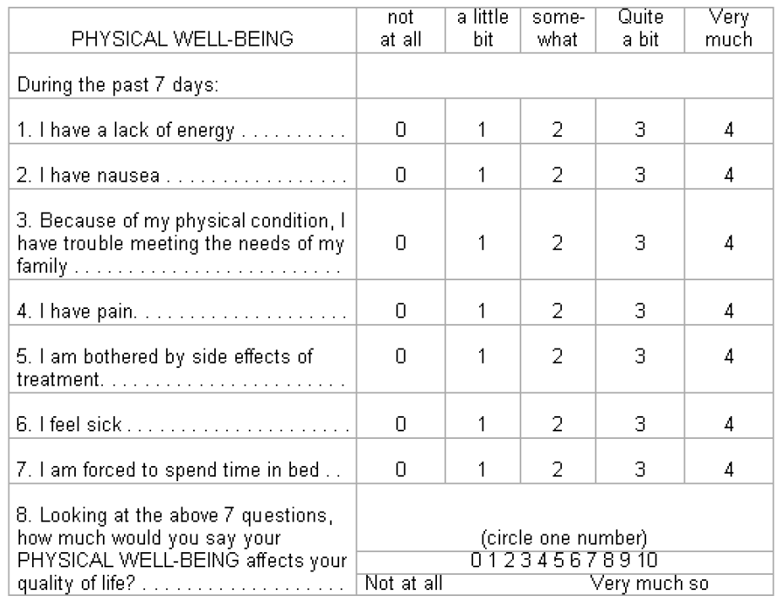

APPENDIX Record Letter (continued) FACT-6

Name:
Medical Record:

Physician:
Study ID:

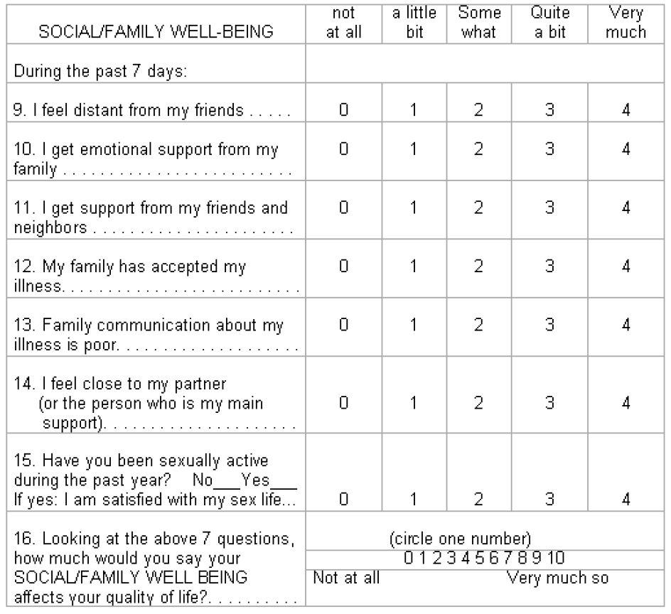

APPENDIX Record Letter (continued) FACT-6

Name:
Medical Record:

Physician:
Study ID:

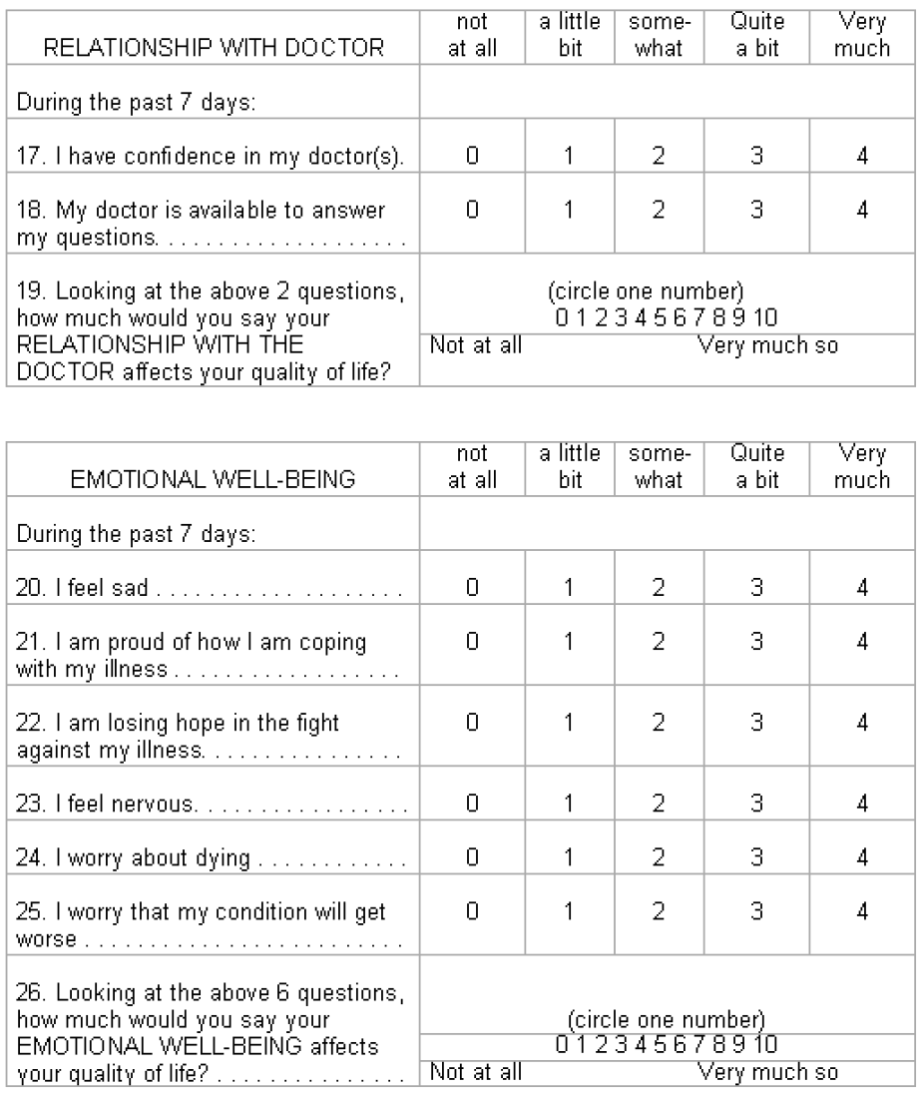

APPENDIX Record Letter (continued)
FACT-6

Name:
Medical Record:

Physician:
Study ID:

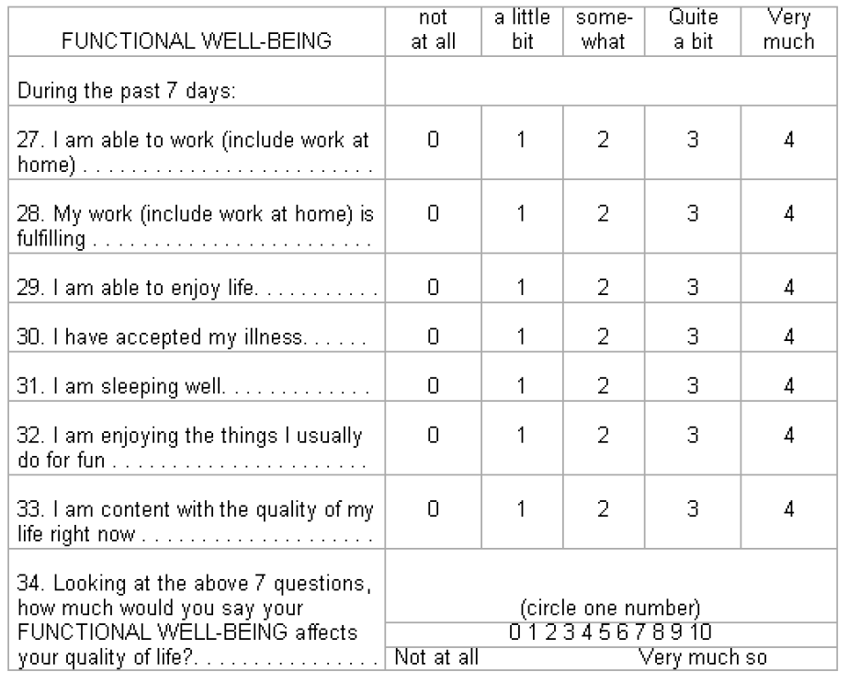

APPENDIX Record Letter

INTERNATIONAL MYELOMA WORKING GROUP CONSENSUS ON DIAGNOSIS OF MM

All three criteria must be met except as noted:

1. Clonal bone marrow plasma cells ≥ 10%

- Presence of serum and/or urinary monoclonal protein (except in patients with true non- secretory multiple myeloma) and

- Evidence of end-organ damage that can be attributed to the underlying plasma cell proliferative disorder, specifically:

(C) Hypercalcemia: serum calcium ≥ 11.5 mg/100 ml or

(R) Renal insufficiency: serum creatinine >1.73 mmol/l)

- Anemia: normochromic, normocytic with a hemoglobin value of >2 g/100 ml below the lower limit of normal or a hemoglobin value <10 g/100 ml

- Bone lesions: lytic lesions, severe osteopenia or pathologic fractures

APPENDIX Record Letter

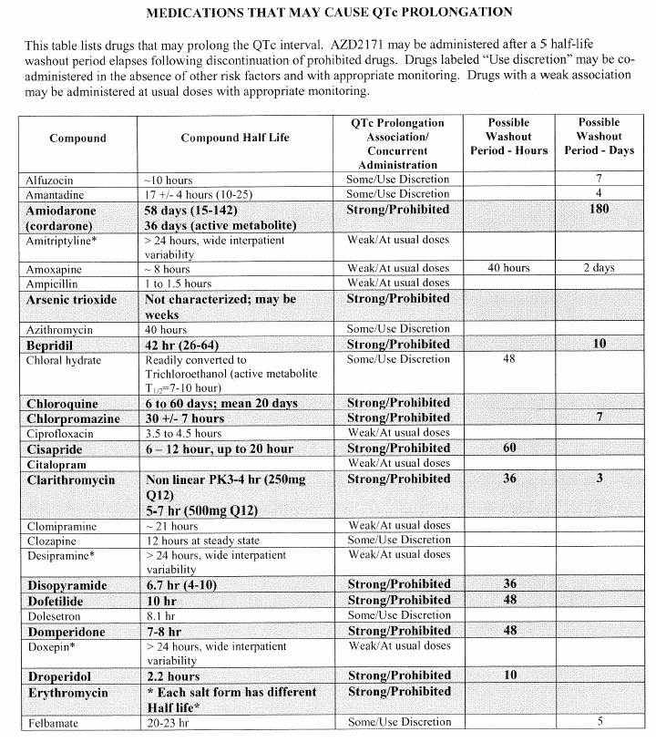
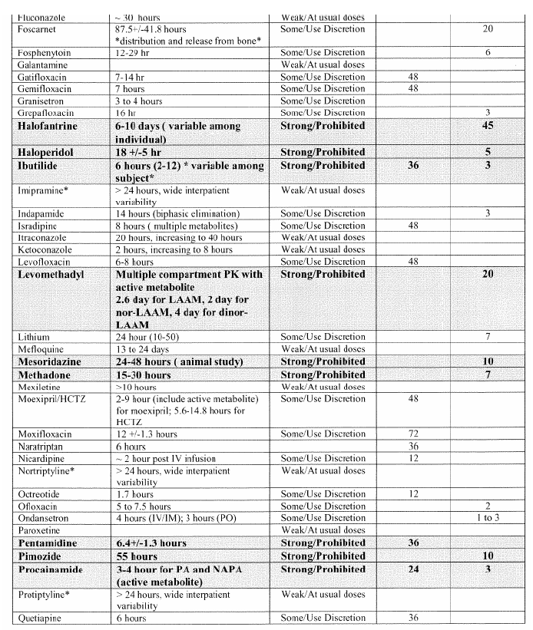

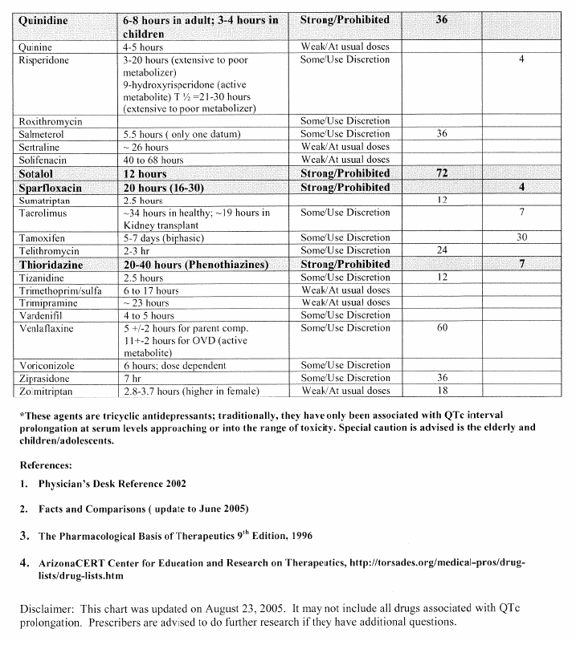

APPENDIX Record Letter

NEW YORK HEART ASSOCIATION (NYHA) CARDIAC CLASSIFICATION

The NYHA classification system relates symptoms to everyday activities and the patient’s quality of life.

Class | Symptoms
Class I (Mild) | No limitation of physical activity. Ordinary physical activity does not cause fatigue, palpitation, or dyspnea (shortness of breath).
Class II (Mild) | Slight limitation of physical activity. Comfortable at rest, but ordinary physical activity results in fatigue, palpitation, or dyspnea.
Class III (Moderate) | Marked limitation of physical activity. Comfortable at rest, but less than ordinary activity causes fatigue, palpitation, or dyspnea.
Class IV (Severe) | Unable to carry out any physical activity without discomfort. Symptoms of cardiac insufficiency at rest. If any physical activity is undertaken, discomfort is increased.

APPENDIX Record Letter PATIENT PILL DIARY
Revise the areas in red to fit the protocol. Delete #2 under instructions and the second column of pills if only one mg or one agent is used. Add additional columns and rows as needed for multiple agents/longer cycles.

Patient Name Protocol # Patient Study ID

Cycle #:
Month #:

INSTRUCTIONS FOR THE PATIENT:
- You will take # of tablets of mg record agent pills each day. Take the tablets [on an empty stomach / with a full glass (8 ox) of water / before or 2 hours after meals / with or without food, as you wish].
- You will take # of tablets of mg record agent pills each day. Take the tablets [on an empty stomach / with a full glass (8 ox) of water / before or 2 hours after meals / with or without food, as you wish].
- Record the date, the number of tablets you took, and what time you took them.
- If you have any comments please record them in the “Comments” column below.
- Please bring your pill bottle and this form to your physician when you come for your next appointment.
- Please sign your name at the bottom of the diary.
Date | Day | # of mg record agent  pills and time taken | # of mg record agent  pills and time taken | Comments
 | 1
 | 2
 | 3
 | 4
 | 5
 | 6
 | 7
 | 8
 | 9
 | 10
 | 11
 | 12
 | 13
 | 14
 | 15
 | 16
 | 17
 | 18
 | 19
 | 20
 | 21
 | 22
 | 23
 | 24
 | 25
 | 26
 | 27
 | 28 |  |  | Add/remove days as needed
Patient’s Signature: Date:

APPENDIX Record Letter
PATIENT PILL DIARY FOR TWICE DAILY DOSING

Add or delete columns and rows and revise the information in red as appropriate for the trial.

Patient Name Patient Study ID
Today’s date / /

Drug
Cycle #:

INSTRUCTIONS FOR THE PATIENT:
- Complete one form every 4 weeks (one treatment cycle).
- You will take record agent tablets twice each day about 12 hours apart. Take the tablets [on an empty stomach / with a full glass (8 ox) of water / before or 2 hours after meals / with or without food, as you wish].
Morning dose: take # of mg tablet(s) [if applicable, and # of mg tablet(s)] Evening dose: take # of mg tablet(s), [if applicable, and # of mg tablet(s)]
- Record the date, the number of tablets of each size that you took, and what time you took them.
- If you have any comments or notice any side effects, please record them in the “Comments” column.
- Please bring this form and your bottle(s) of record agen to your physician when you return for each appointment.
- Please sign your name at the bottom of the diary.
Day | Date | Time of morning dose | # of tablets taken |  |  | Time of evening dose | # of tablets taken |  |  | Comments
 |  |  | mg | line  mg |  |  | mg | mg
1
2
3
4
5
6
7
8
9
10
11
12
13
14
15
16
17
18
19
20
21
22
23
24
25
26
27
28 |  |  |  |  |  |  |  |  |  | Add/remove days as needed
Patient’s Signature: Date:

APPENDIX Record Letter POTENTIAL CYP3A4 INTERACTIONS
CYP3A4 Substrates
Albuterol Alfentanil Alprazolam Amiodarone Amlodipine Amprenavir Aprepitant Aripiprazole Atazanavir Atorvastatin Benzphetamine Bisoprolol Bortezomib Bosentan Bromazepam Bromocriptine Budesonide Buprenorphine Buspirone Busulfan Carbamazepine Cerivastatin Chlordiazepoxide Chloroquine Chlorpheniramine Cilostazol Cisapride Citalopram Clarithromycin Clobazam Clonazepam Clorazepate Cocaine Colchicine Conivaptan Cyclophosphamide Cyclosporine Dantrolene Dapsone  Dasatinib (1) Delvirdine Diazepam | Dihydroergotamine Diltiazem Disopyramide Docetaxel  Doxepin Doxorubicin Doxycycline Efavirenz Eletriptan Enalapril Eplerenone Ergoloid mesylates Ergonovine Ergotamine Erythromycin Escitalopram Estradiol Estrogens,  conj., synthetic Estrogens,  conj., equine Estrogens,  conj., esterified Estrone Estropipate Ethinyl estradiol Ethosuximide Etoposide Exemastane Felbamate Felodipine Fentanyl Flurazepam Flutamide Fluticasone Fosamprenavir Gefitinib Haloperidol Ifosfamide Imatinib Indinavair Irinotecan | Isosorbide Isosorbide, dinitrate  Isosorbide mononitrate Isradipine  Itraconazole Ketamine Ketoconazole Lansoprazole Letrozole Levonorgestrel Lidocaine Losartan Lovastatin  Medroxyprogesterone Mefloquine Mestranol  Methadone Methylergonovine Methysergide Miconazole Midazolam Miglustat Mirtazapine Modafinil Montelukast Moricizine Nateglinide Nefazodone Nelfinavir Nevirapine Nicardipine Nifedipine Nimodipine Nisoldipine Norethindrone Norgestrel Ondansetron Paclitaxel Pergolide Phencyclidine Pimozide Pipotiazine Primaquine | Progesterone Quetiapine Quinidine Rabeprazole Ranolazine Repaglinide Rifabutin Ritonavir Salmetrol Saquinavir Sibutramine Sildenafil Simvastatin Sirolimus Spiramycin Sufentanil Sunitinib Tacrolimus Tamoxifen Tamsulosin Telithromycin Teniposide Tetracycline Theophylline Tiagabine Ticlopidine Tipranavir Tolterodine Toremifene Trazodone Triazolam Trimethoprim Trimipramine Troleandomycin Vardenafil Venlafaxine Verapamil Vinblastine Vincristine Vinorelbine Zolpidem Zonisamide Zopiclone

APPENDIX Record Letter (continued)

POTENTIAL CYP3A4 INTERACTIONS

CYP3A4 Inhibitors
Acetaminophen Acetazolamide Amiodarone Amlodipine Amprenavir Anastrozole Aprepitant Atazanavir Atorvastatin Azelastine Azithromycin Betamethasone Bortezomib Bromocriptine Caffeine Cerivastatin Chloramphenicol Chlorzoxazone Cimetidine Ciprofloxacin Cisapride Clarithromycin Clemastine Clofazimine Clotrimazole Clozapine Cocaine Conivaptan  Cyclophosphamide Cyclosporine Danazol  Dasatinib (1) Delvirdine Desipramine Dexmedetomidine Diazepam | Diclofenac Dihydroergotamine Diltiazem Disulfiram Docetaxel Doxorubicin Doxycycline Drospirenone Efavirenz Enoxacin Entacapone Ergotamine Erythromycin Ethinyl estradiol Etoposide Felodipine Fentanyl Fluconazole Fluoxetine Fluvastatin Fluvoxamine Fosamprenavir Glyburide Grapefruit Juice(2) Haloperidol Hydralazine Ifosfamide Imatinib  Indinavair Irbesartan Isoniazid Isradipine Itraconazole Ketoconazole Lansoprazole Lidocaine | Lomustine Losartan Lovastatin Mefloquine Mestranol Methadone Methimazole Methoxsalen  Methylprednisolone Metronidazole Miconazole Midazolam Mifepristone Mirtazapine Mitoxantrone Modafinil Nefazodone Nelfinavir Nevirapine Nicardipine Nifedipine Nisoldipine Nizatidine Norfloxacin Olanzapine Omeprazole Orphenadrine Oxybutynin Paroxetine Pentamidine Pergolide Phencyclidine Pilocarapine Pimozide Pravastatin Prednisolone | Primaquine Progesterone Propofol Propoxyphene Quinidine Quinine Quinupristin Rabeprazole Ranolazine Risperidone Ritonavir Saquinavir Selegiline Sertraline Sildenafil Sirolimus Sulconazole Tacrolimus Tamoxifen Telithromycin Teniposide Testosterone Tetracycline Ticlopidine Tranylcypromine Trazodone Troleandomycin Valproic Acid Venlafaxine Verapamil Vinblastine Vincristine Vinorelbine Voriconazole Zafirlukast Ziprasidone

APPENDIX Record Letter (continued)

POTENTIAL CYP3A4 INTERACTIONS

CYP3A4 Inducers
Aminoglutethimide | Nevirapine | Phenytoin | Rifapentine
Carbamazepine | Oxcarbazepine | Primidone | St. John’s Wort (3)
Fosphenytoin | Pentobarbital | Rifabutin
Nafcillin | Phenobarbital | Rifampin

When drugs classified as ‘substrates’ are co-administered with (Study Agent), there is the potential for higher concentrations of the ‘substrate’. When (Study Agent) is co-administered with compounds classified as ‘inhibitors’, increased plasma concentrations of (Study Agent) is the potential outcome. The co-administration of ‘inducers’ would potentially lower plasma (Study Agent) concentrations.

Note: Adapted from Cytochrome P450 Enzymes: Substrates, Inhibitors, and Inducers. In: Lacy CF, Armstrong LL, Goldman MP, Lance LL eds. Drug Information Handbook 15TH ed. Hudson, OH; LexiComp Inc. 2007: 1899-1912.
Only major substrates and effective inducers are listed.
Additional information for drug interactions with cytochrome P450 isoenzymes can be found at http://medicine.iupui.edu/flockhart/.

  - Investigator’s Brochure: Dasatinib (BMS 354825). Bristol-Myers Squibb. October 2006.

  - Malhotra et al. (2001). Clin Pharmacol Ther. 69:14-23.

  - Mathijssen et al. (2002). J Natl Cancer Inst. 94:1247-1249.

  - Frye et al. (2004). Clin Pharmacol Ther. 76:323-329.

Updated on May 1, 2007

APPENDIX Record Letter
RANO CRITERIA FOR HIGH-GRADE GLIOMAS

Criteria for Determining First Progression Depending on Time From Initial Chemotherapy

First Progression | Definition
Progressive disease < 12 weeks after completion of Chemoradiotherapy | Progression can only be defined using diagnostic imaging if there is new enhancement outside of the radiation field (beyond the high-dose region or 80% isodose line) or if the is unequivocal evidence of viable tumor on histopathologic sampling (e.g., solid tumor areas [i.e., > 70% tumor cells nuclei in areas], high or progressive increase in MIB-1 proliferation index compared with prior biopsy, or evidence for histologic progression or increased anaplasia in tumor). Note: given the difficulty of differentiating true progression from pseudoprogression, clinical decline alone, in the absence of radiographic or histologic confirmation of progression, will not be sufficient for definition of progressive disease in the first 12 weeks after completion of concurrent chemoradiotherapy.
Progressive disease > 12 weeks after Chemoradiotherapy completion | - New contrast-enhancing lesion outside of radiation field on decreasing, stable, or increasing doses of corticosteroids.  - Increase by > 25% in the sum of the products of perpendicular diameters between the first postradiotherapy scan, or a subsequent scan with smaller tumor size, and the scan at least 12 weeks or later on stable or increasing doses of corticosteroids.  - Clinical deterioration not attributable to concurrent medication or comorbid conditions is sufficient to declare progression on current treatment, but not for entry onto a clinical trial for recurrence.  - For patients receiving antiangiogenic therapy, significant increase in T2/FLAIR non-enhancing lesion may also be considered progressive disease. The increased T2/FLAIR must have occurred with the patient on stable or increasing doses of corticosteroids compared with baseline scan or best response after initiation of therapy and not be a result of comorbid events (e.g., effects of radiation therapy, demyelination, ischemic injury, infection, seizures, postoperative changes, or other treatment effects).
Abbreviation: FLAIR, fluid-attenuated inversion recovery.

APPENDIX Record Letter (continued) RANO CRITERIA FOR HIGH-GRADE GLIOMAS

Criteria for Response Assessment Incorporating MRI and Clinical Factors
Response | Criteria
Complete Response | Requires all of the following: complete disappearance of all enhancing measurable and non-measurable disease sustained for at least 4 weeks; no new lesions; stable or improved non-enhancing (T2/FLAIR) lesions; patients must be off corticosteroids (or on physiologic replacement doses only); and stable or improved clinically. Note: Patients with non-measurable disease only cannot have a complete response; the best response possible is stable disease.
Partial Response | Requires all of the following: > 50% decrease compared with baseline in the sum of products of perpendicular diameters of all measurable enhancing lesions sustained or at least 4 weeks; no progression of non-measurable disease; no new lesions; stable or improved non-enhancing T2/FLAIR) lesions on same or lower dose of corticosteroids compared with baseline scan; the corticosteroid dose at the time of the scan evaluation should be no greater than the dose at time of baseline scan; and stable or improved clinically. Note: Patients with non-measurable disease only cannot have a partial response; the best response possible is stable disease.
Stable Disease | Requires all of the following: does not qualify for complete response, partial response, or progression; stable non-enhancing (T2/FLAIR) lesions on same or lower dose of corticosteroids compared with baseline scan. In the event that the corticosteroid dose was increased for new symptoms and signs without confirmation of disease progression on Neuroimaging, and subsequent follow- up imaging shows that this increase in corticosteroids was required because of disease progression, the last scan considered to show stable disease will be the scan obtained when the corticosteroid dose was equivalent to the baseline dose.
Progression | Defined by any of the following: > 25% increase in sum of the products of perpendicular diameters of enhancing lesions compared with the smallest tumor measurement obtained either at baseline (if no decrease) or best response, on stable or increasing doses of corticosteroids*; significant increase in T2/FLAIR non-enhancing lesion on stable or increasing doses of corticosteroids compared with baseline scan or best response after initiation of therapy* not caused by comorbid events (e.g., radiation therapy, demyelination, ischemic injury, infection, seizures, postoperative changes, or other treatment effects); any new lesion; clear clinical deterioration not attributable to other causes apart form the tumor (e.g., seizures, medication adverse effects, complications of therapy, cerebrovascular events, infection, and so on) or changes in corticosteroids dose; failure to return for evaluation as a result of death or deteriorating condition; or clear progression of non- measurable disease.
NOTE: All measurable and non-measurable lesions must be assessed using the same techniques as at baseline.
Abbreviations: MRI, magnetic resonance imaging; FLAIR, fluid-attenuated inversion recovery.
* Stable doses of corticosteroids include patients not on corticosteroids.

APPENDIX Record Letter VES-13

Name:
Medical Record:

Physician:
Study ID:

VES-13